# Generics_Class

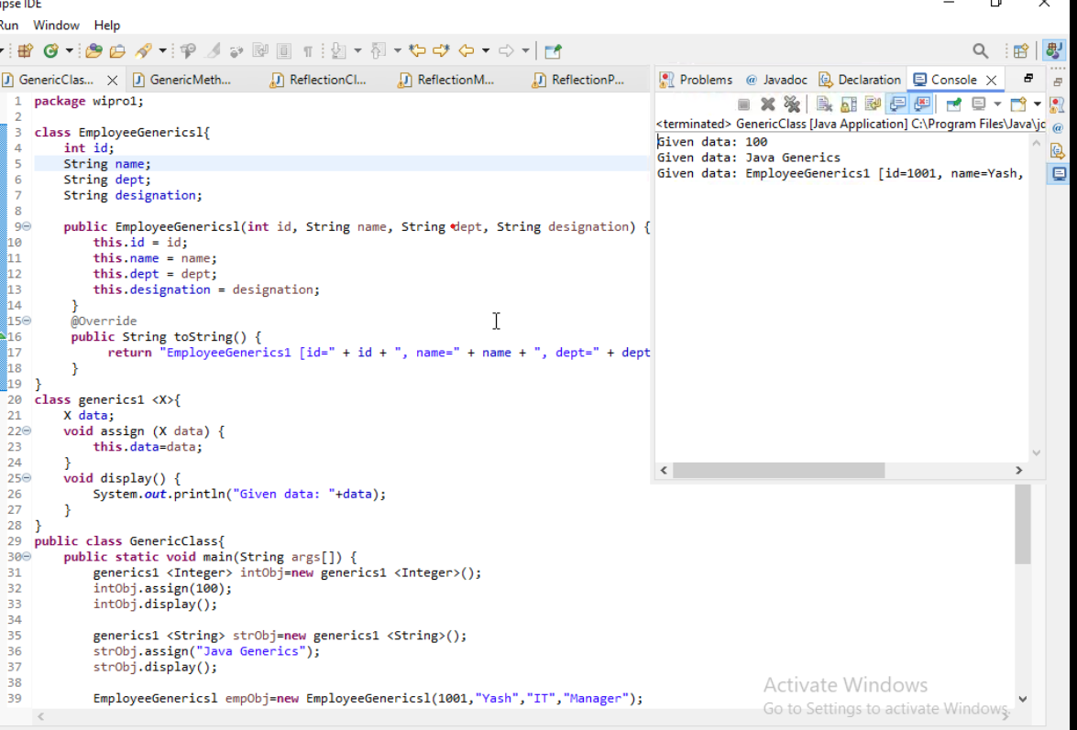

# Generic_Method

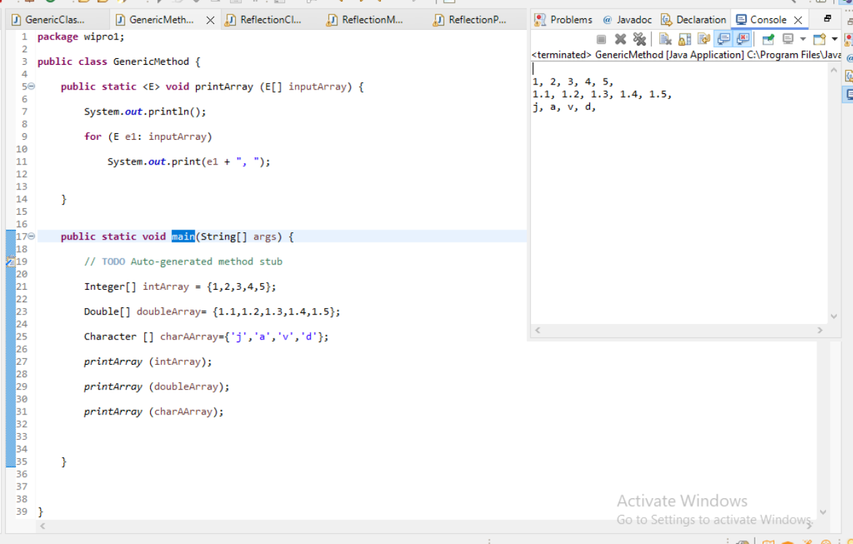

# Java Reflection

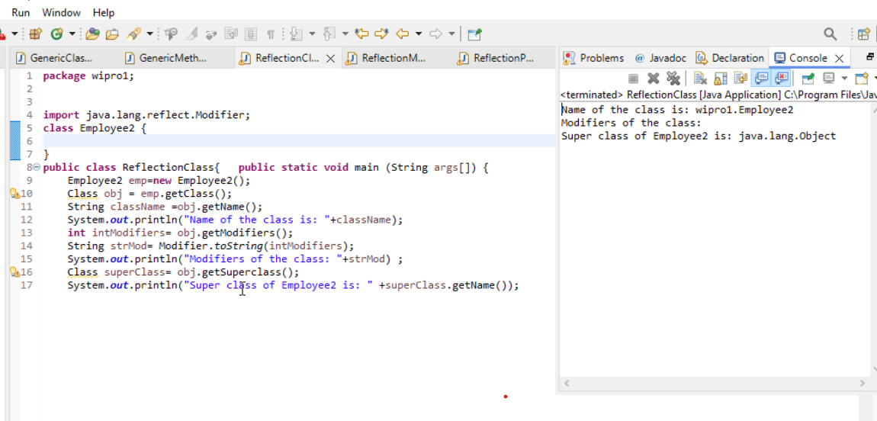

# Reflection_Method

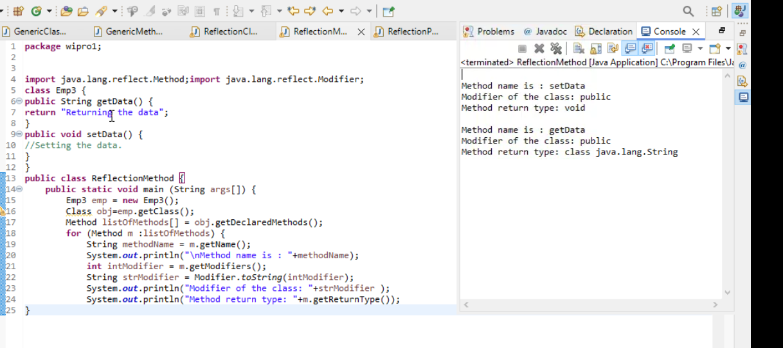

# Reflection Accessing Private attribute

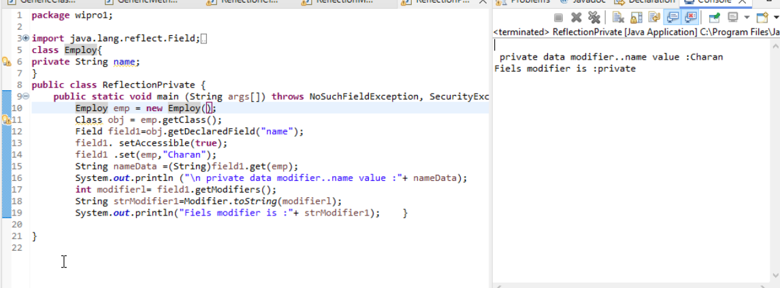

# Lambda Expression

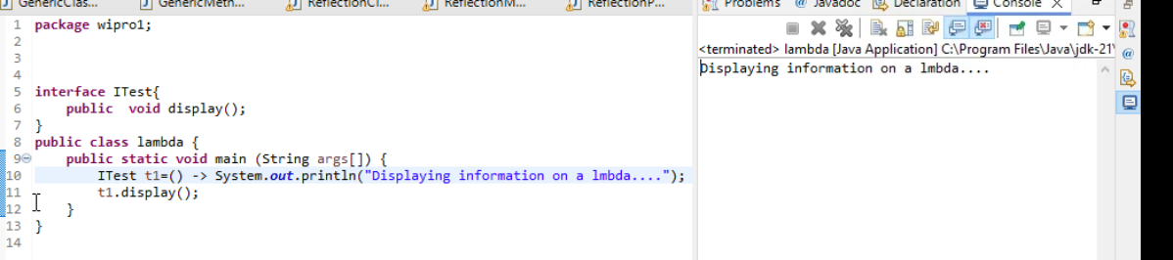

# Lambda with Argument

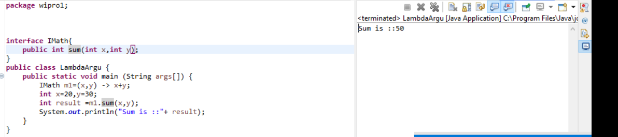

# Preddicate

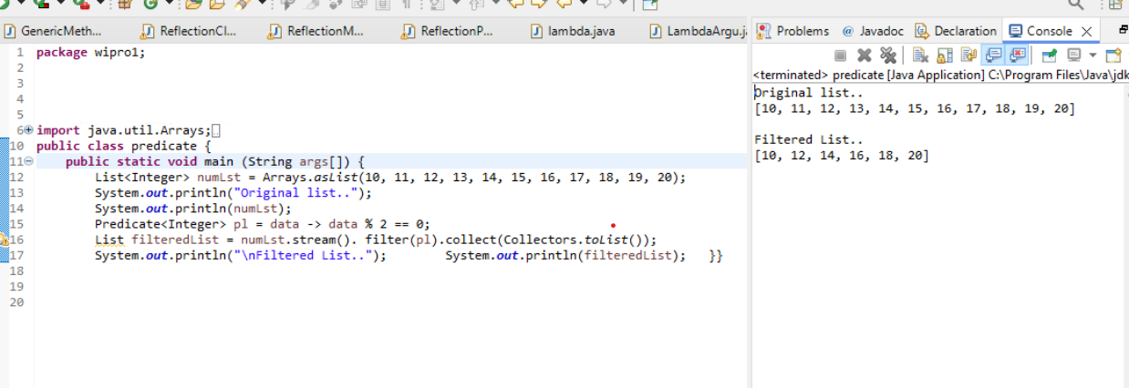

# Method Referencing

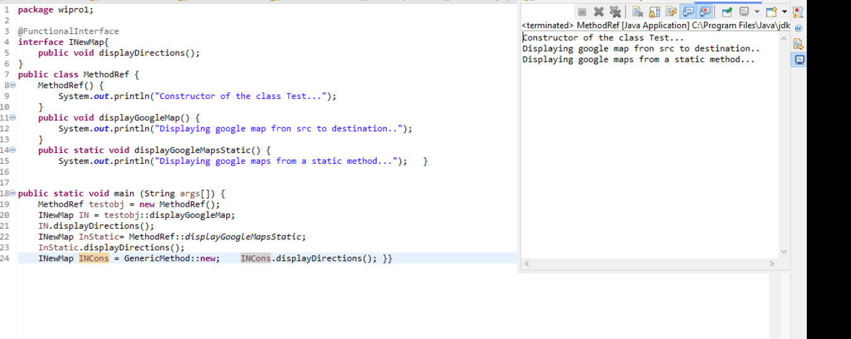

# Day 2

# **File Operations**

# **FileWriter**

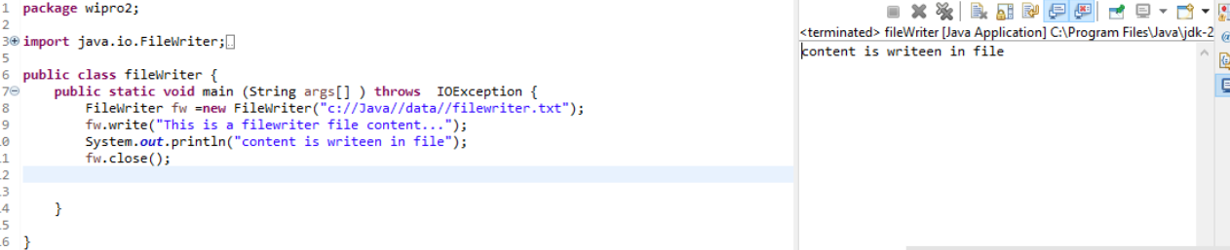

# File Reader

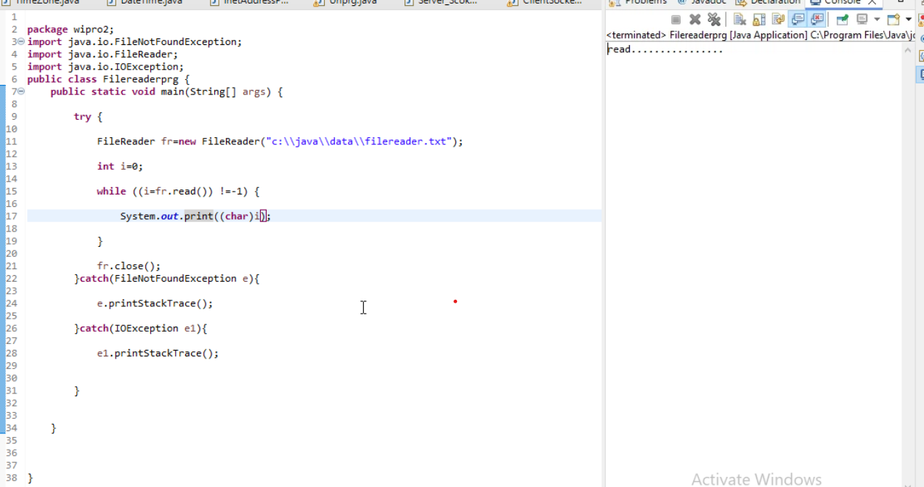

# BufferedWriter

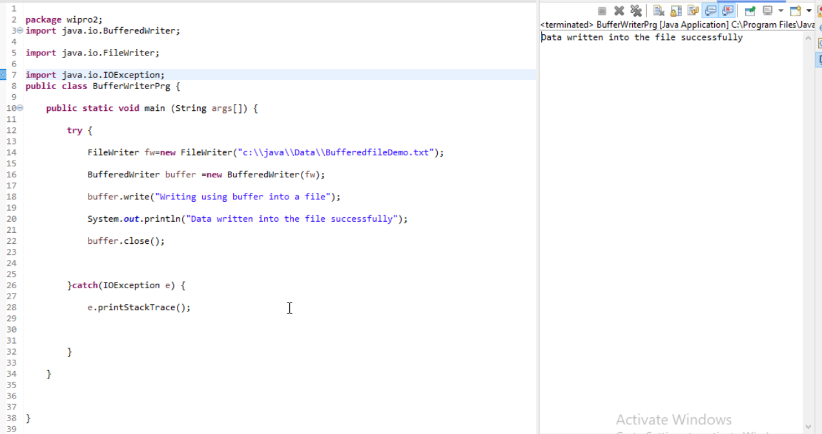

# BufferedReader

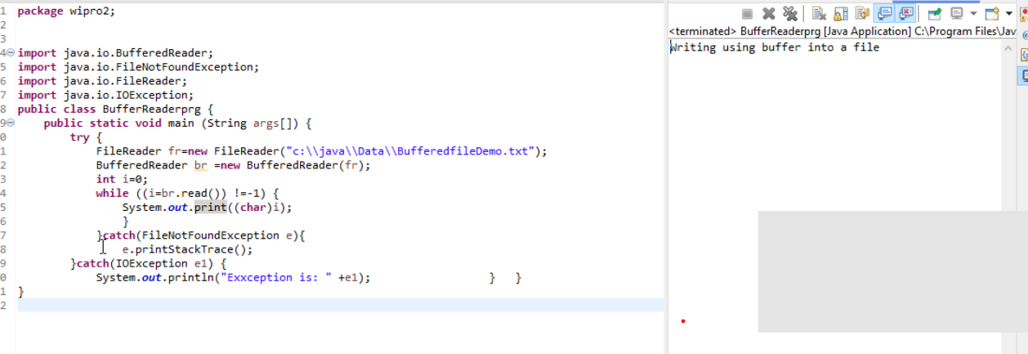

# Serialization

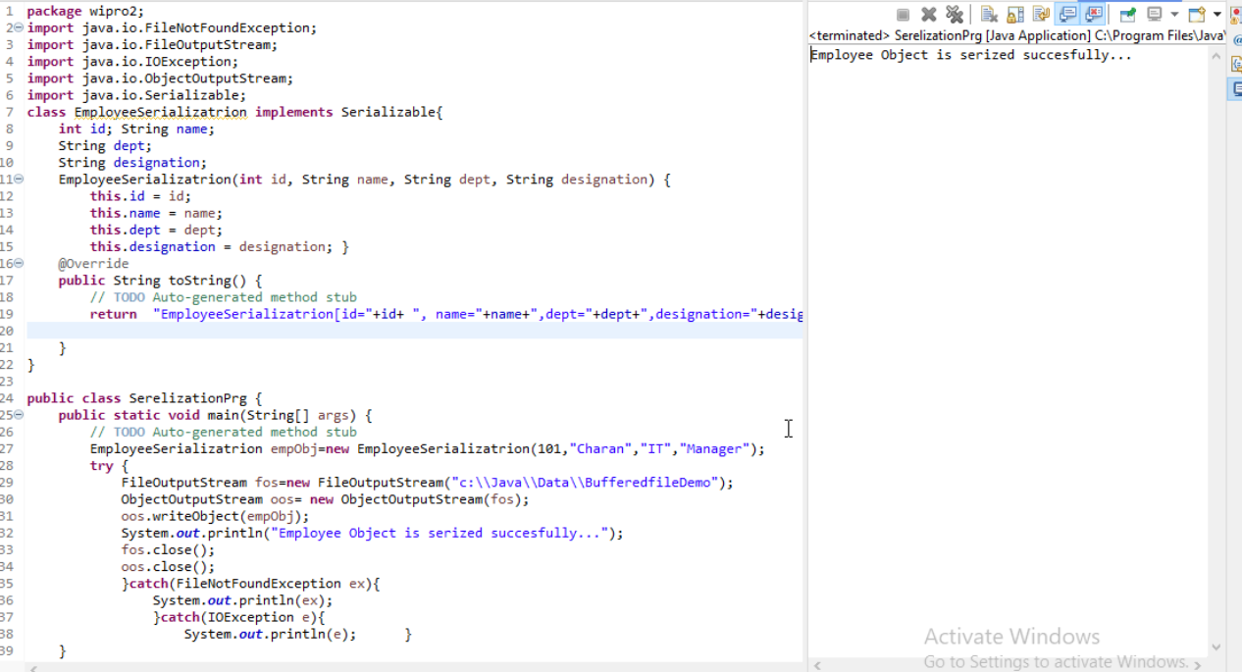

# Deserialization

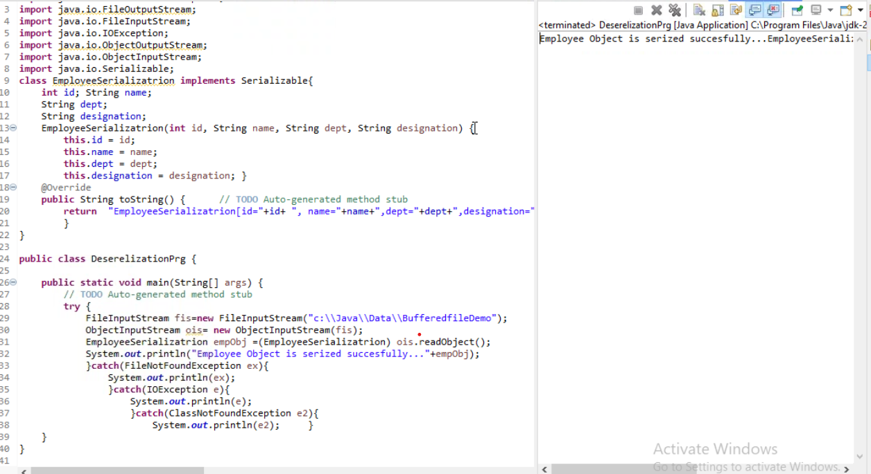

# Directory Operations

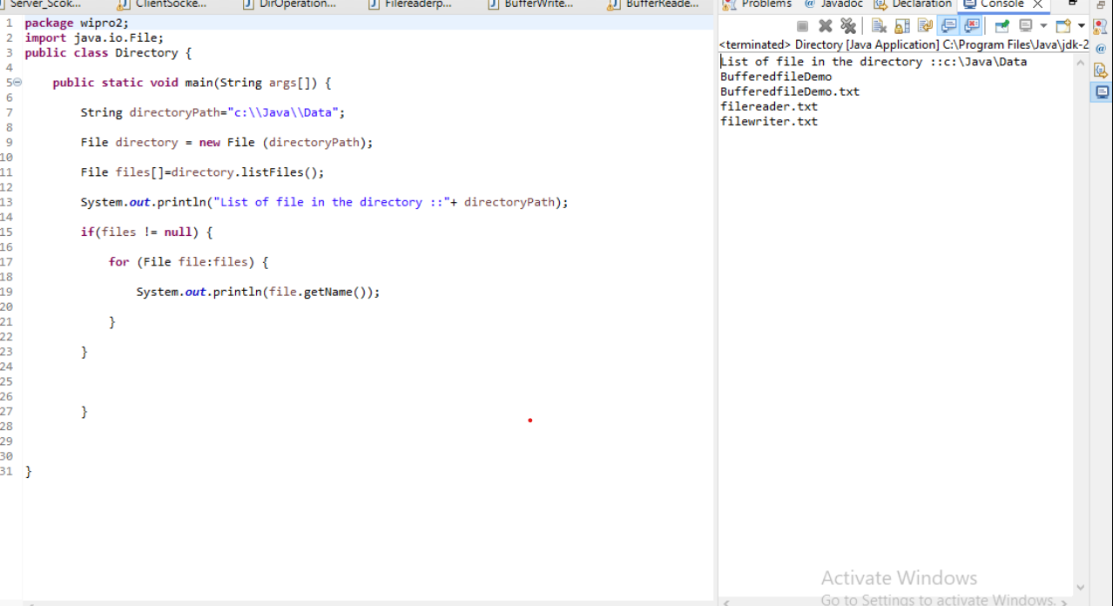

# Socket Programming

## ServerSocket

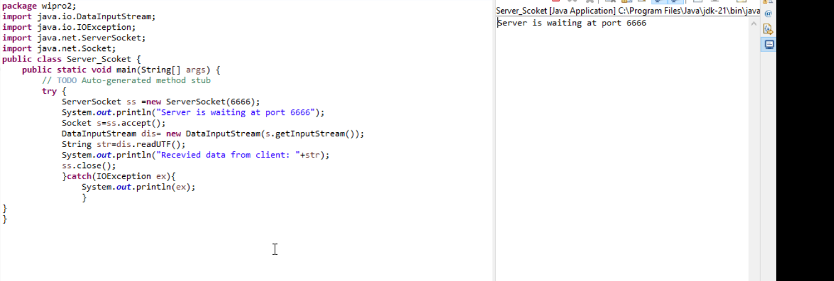

## ClientSocket

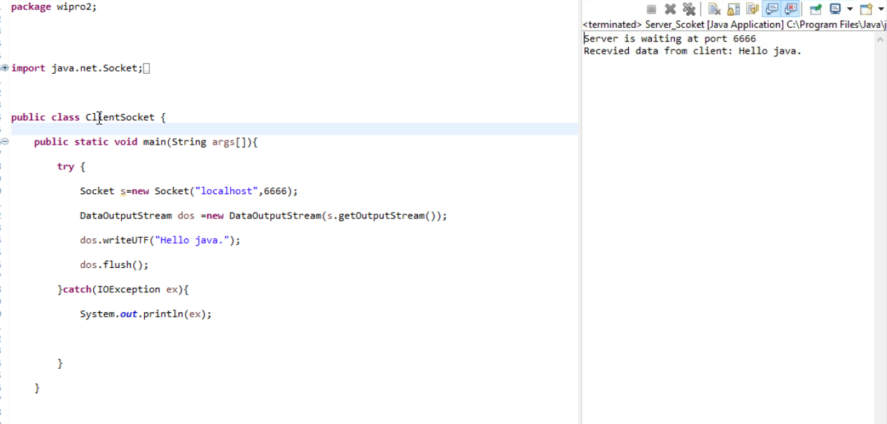

## URL

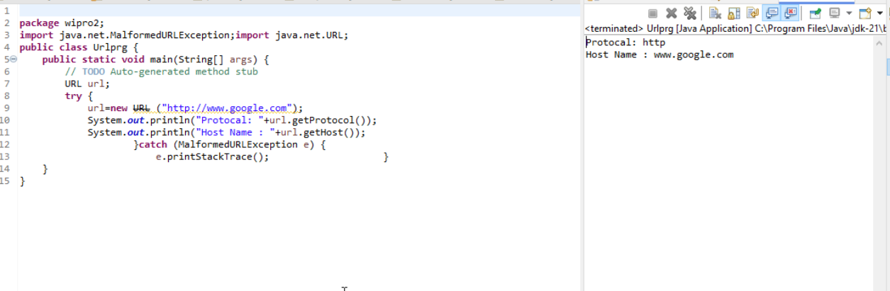

InetAddress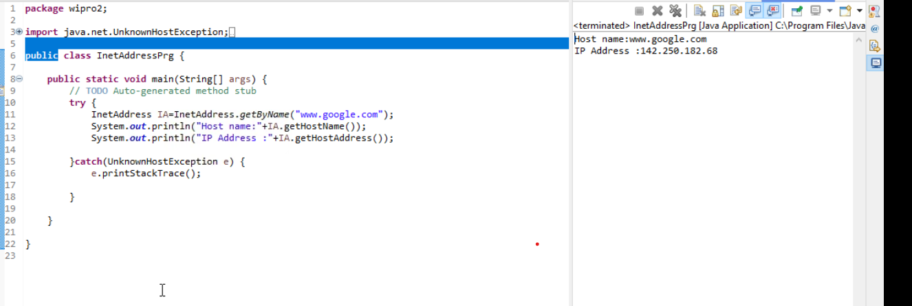

## LocalDate, LocalTime and LocalDateTime

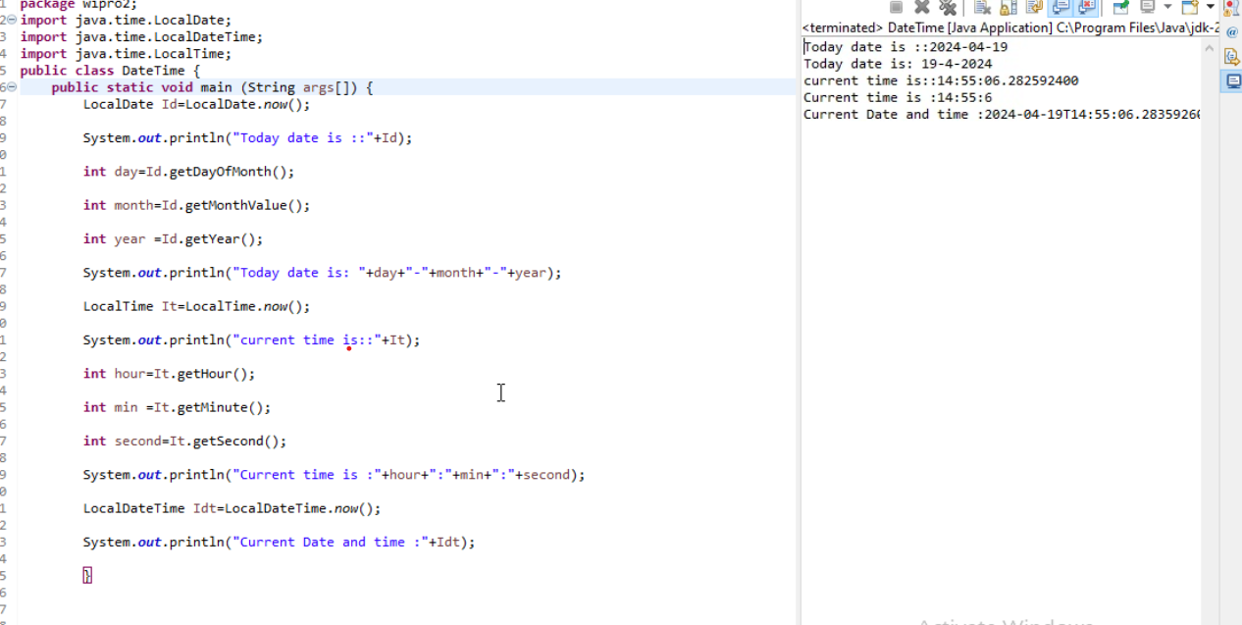

## Time Zones with ZoneIds

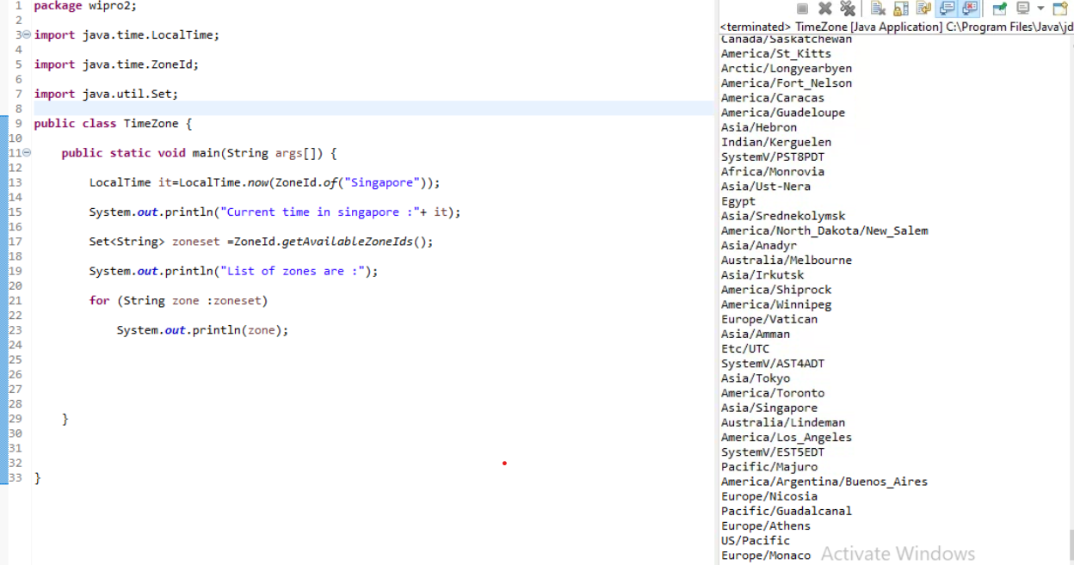

## TemporalAdjusters

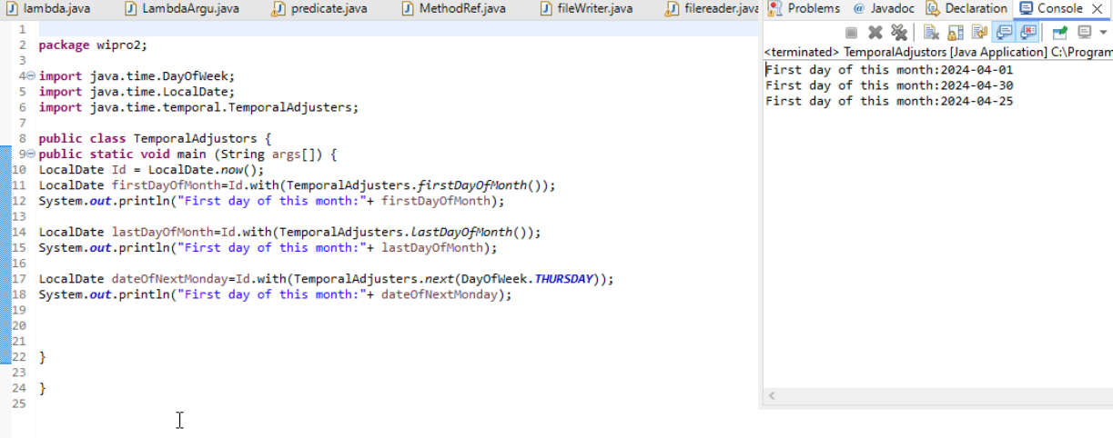

## Period

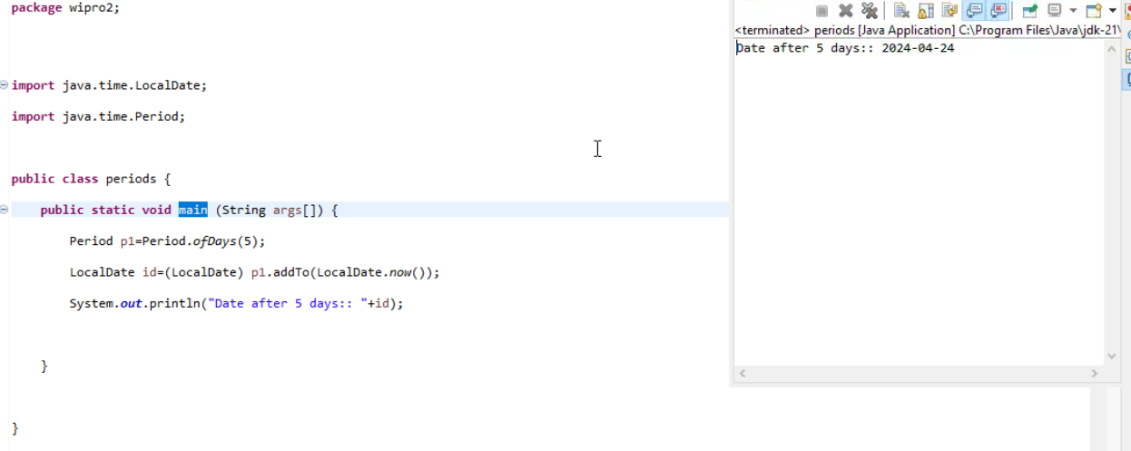

# Day3

# JDBC

## Insert, Update and Delete operations from JDBC.

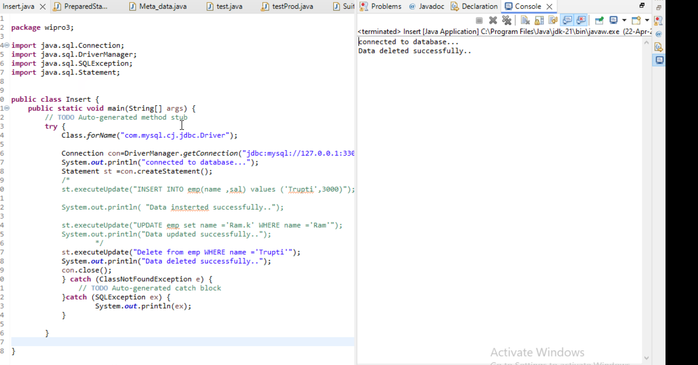

## PreparedStatement

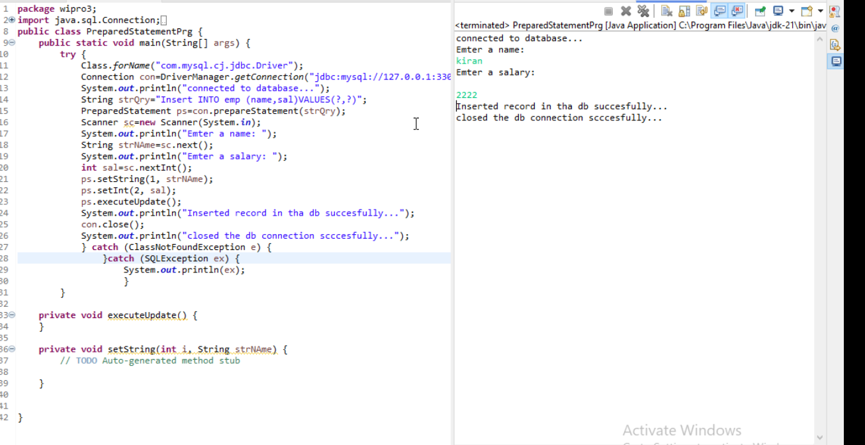

## Select from ResultSet

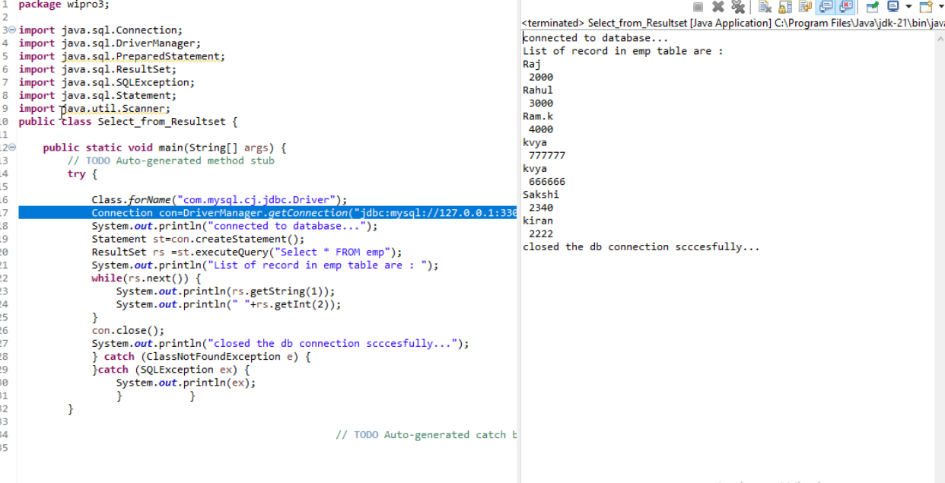

## Database Meta data

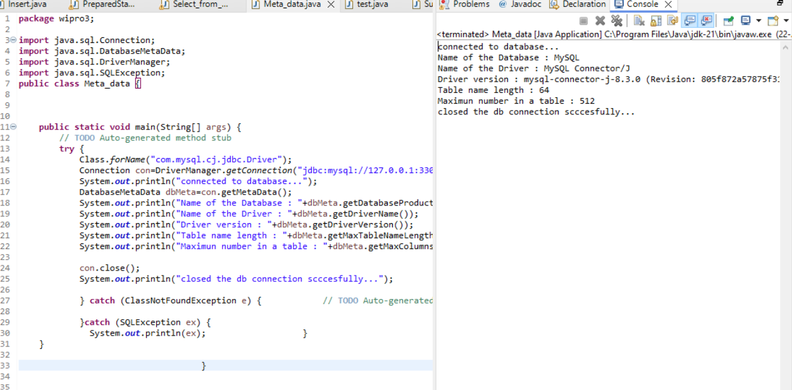

## Stored Procedure

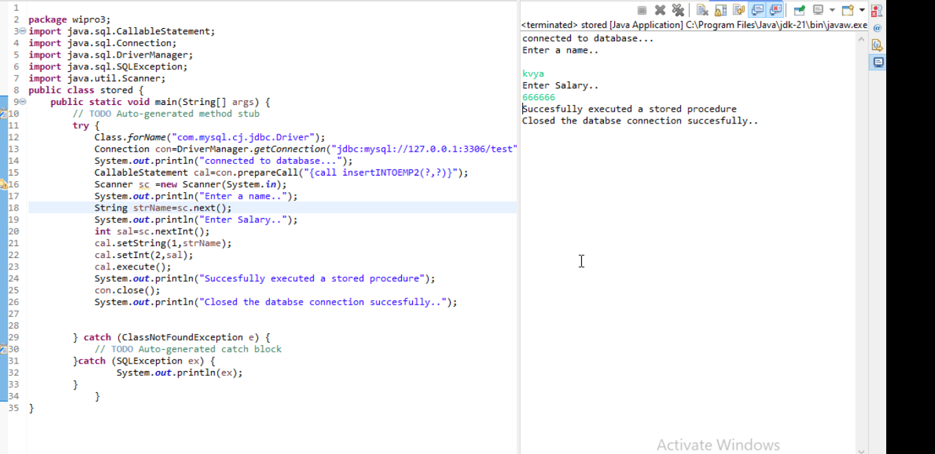

## Junit

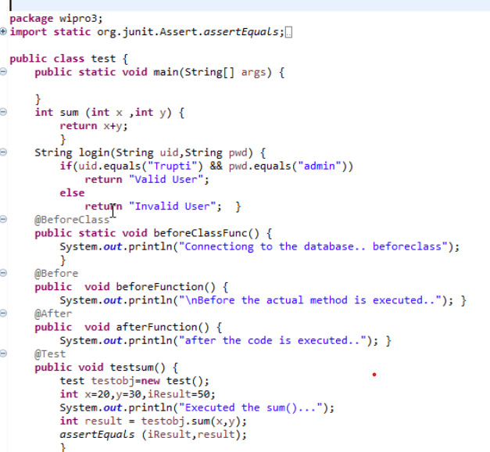

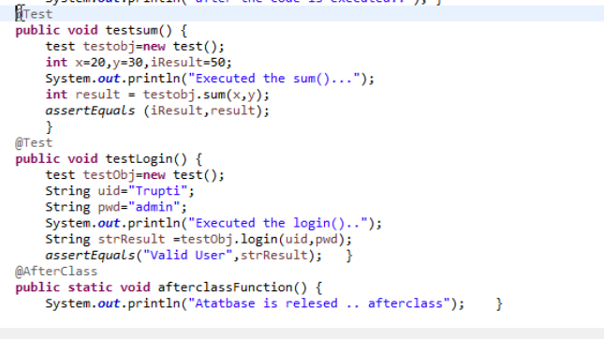

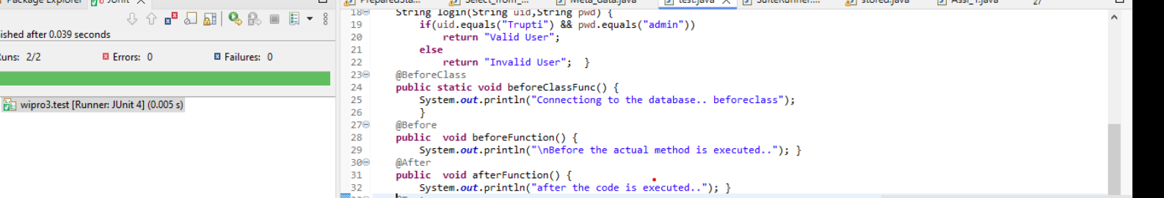

# Suites

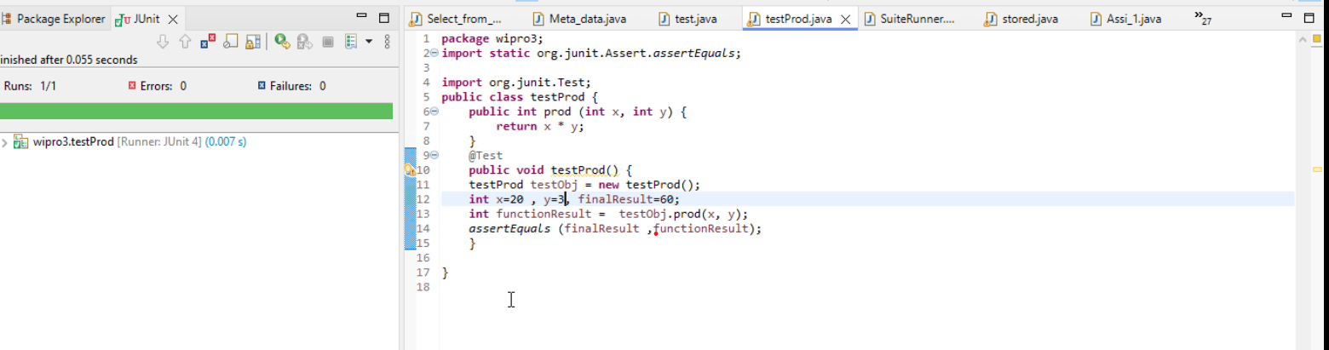

## Create a suite file and combine all the java testing code.

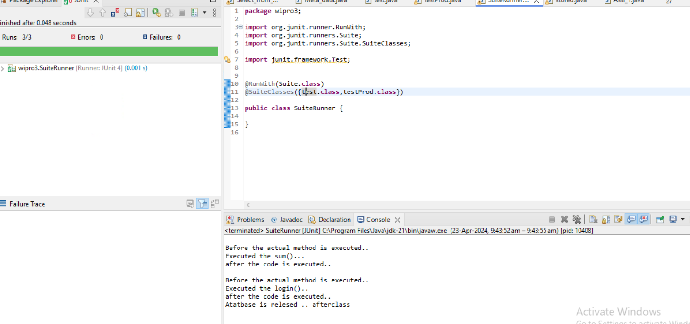

**If the user enters 1, take the data from the user and insert the record. If the user enters 2 as the choice update the data, If the user chooses 3 then take the record to be deleted from the user and delete it. If the user chooses 5 then display all the records from the table. If the user chooses 5 then exit the program. Until the user chooses 5, this loop should go on.**

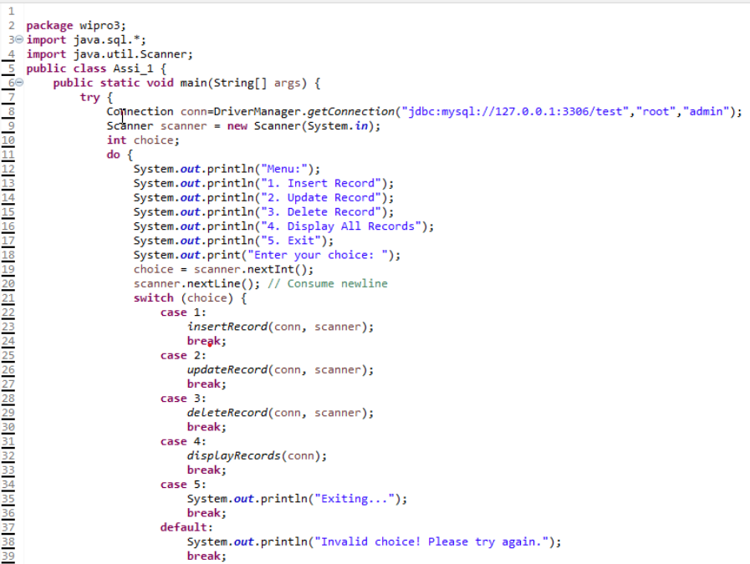

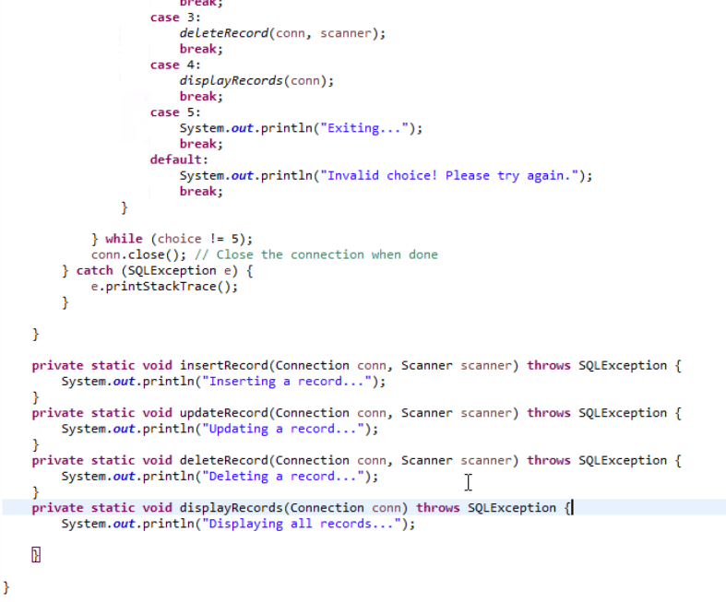

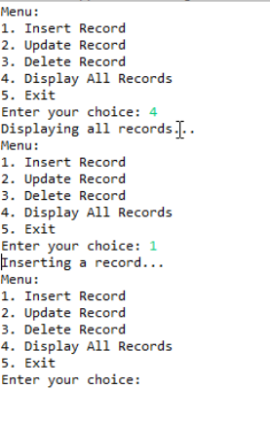

**Day4**

Design patterns

**Singleton**

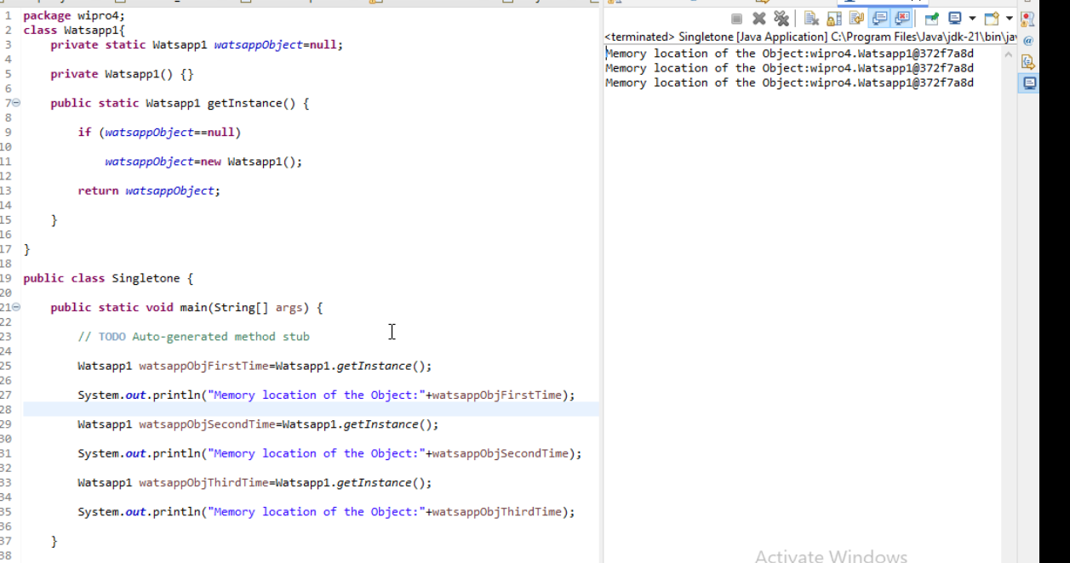

**Runtime Polymorphism**

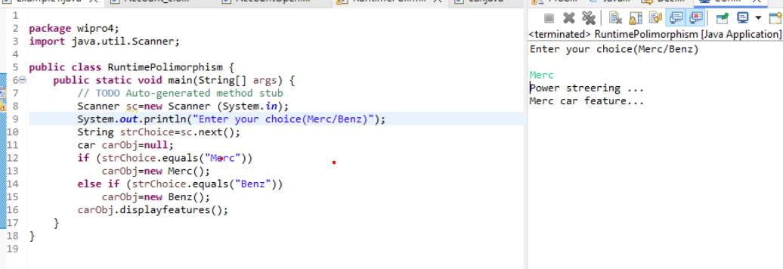

Factory Pattern

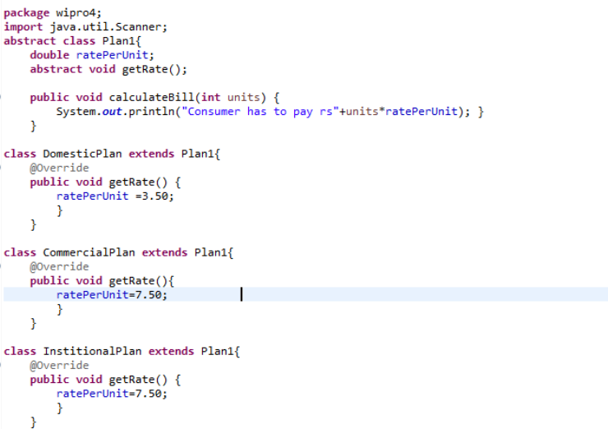

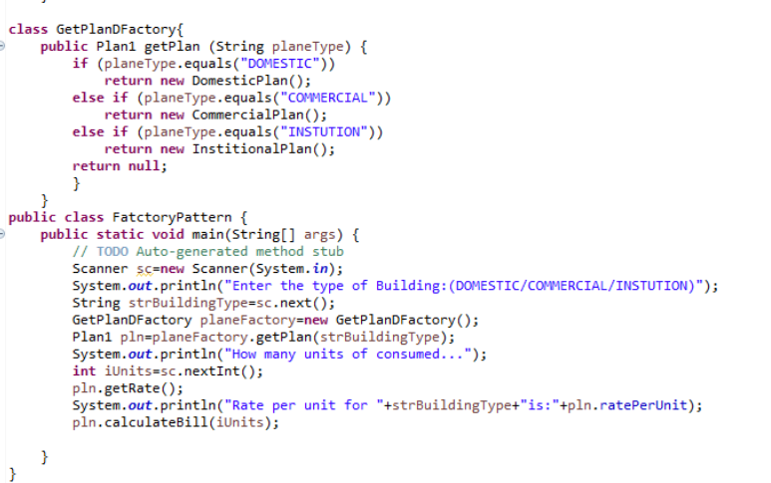

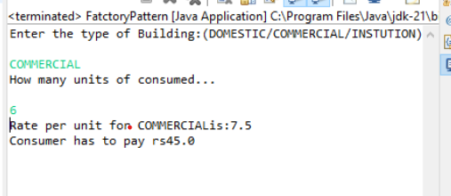

**Day5**

Factory Pattern

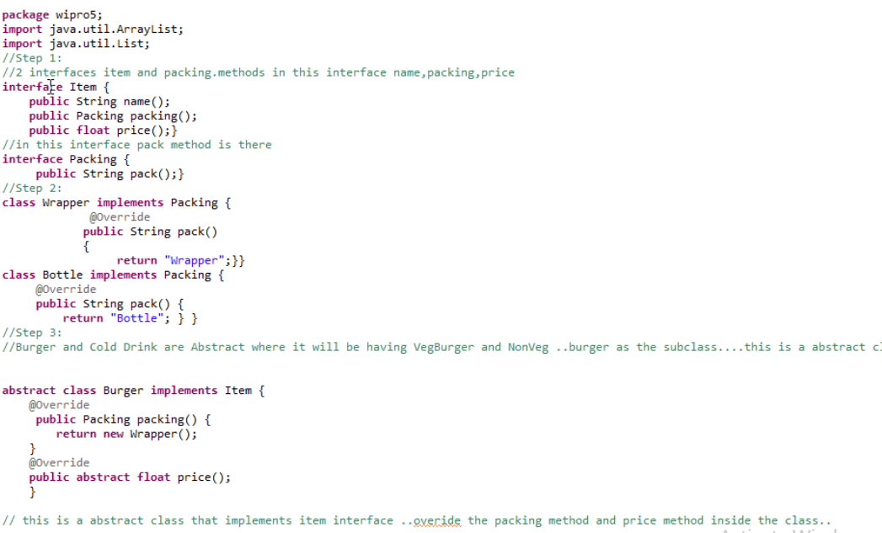

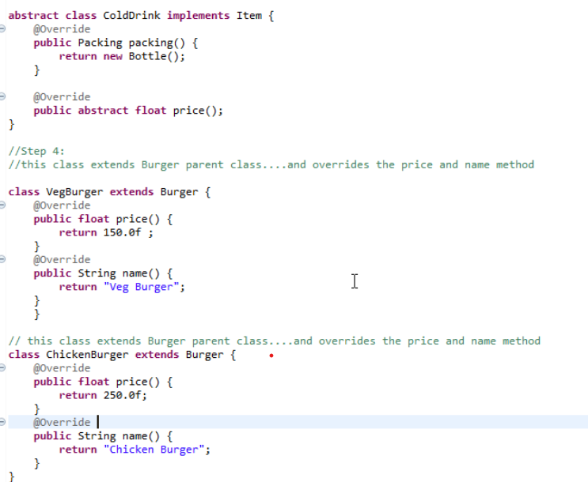

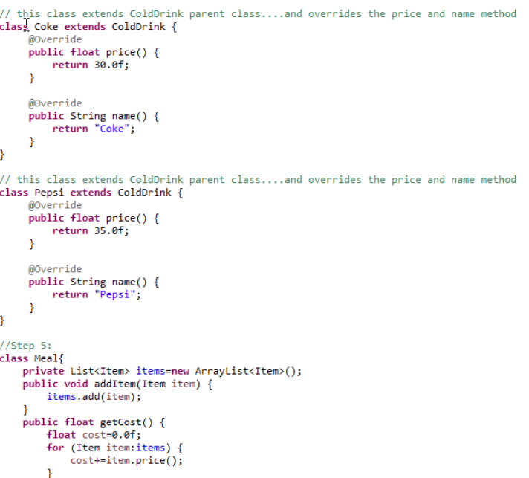

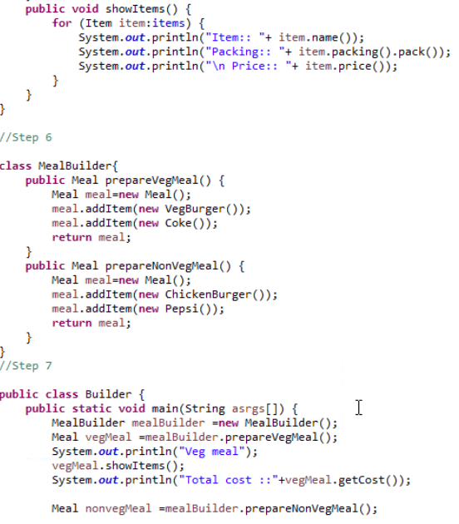

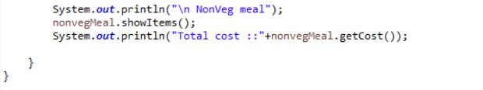

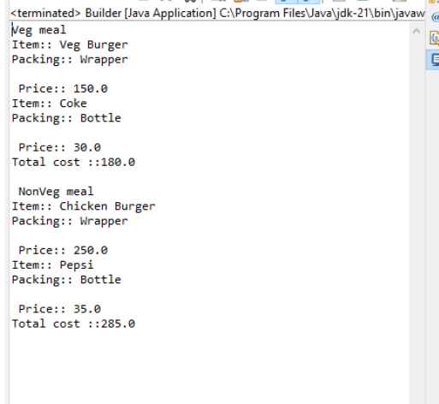

Develop a factory pattern for bank loans. When the user gives the type of loan, it should return the interest rate for the selected loan.

(a) Educational Loan = 10%

(b) Housing Loan - 12%

 (c) Business Loan - 15%

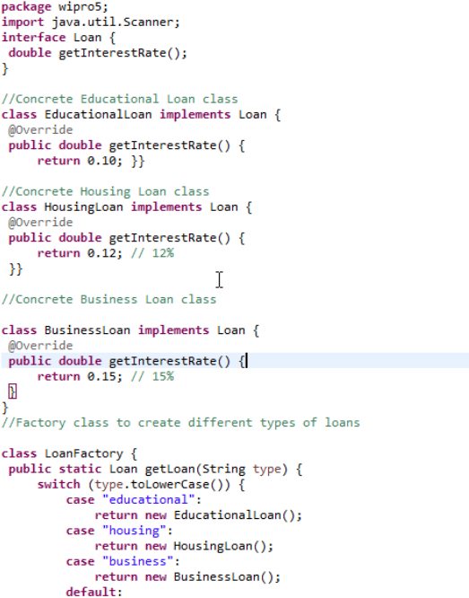

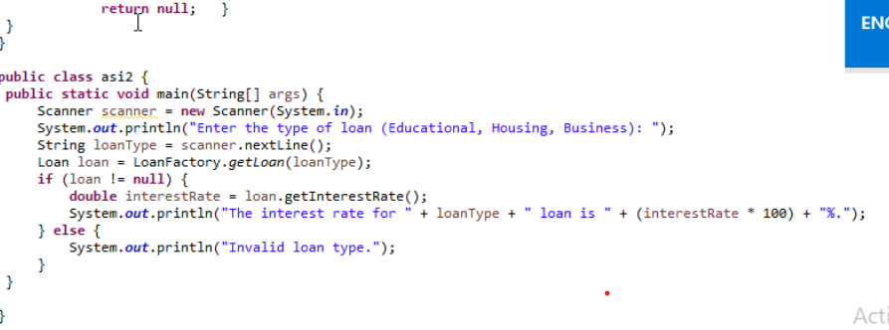

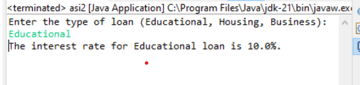

Build a builder pattern code for Shopping. User can shop for grocery, vegetables and fuits.

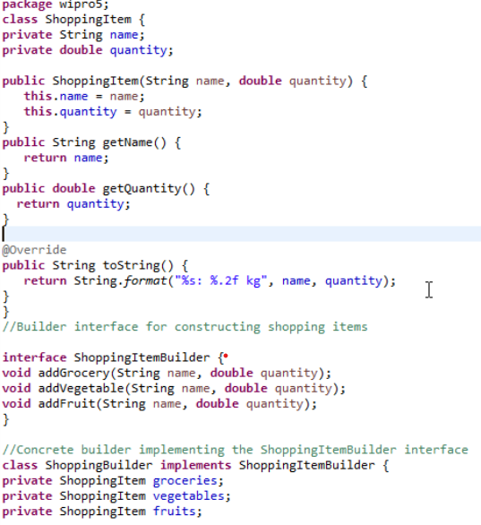

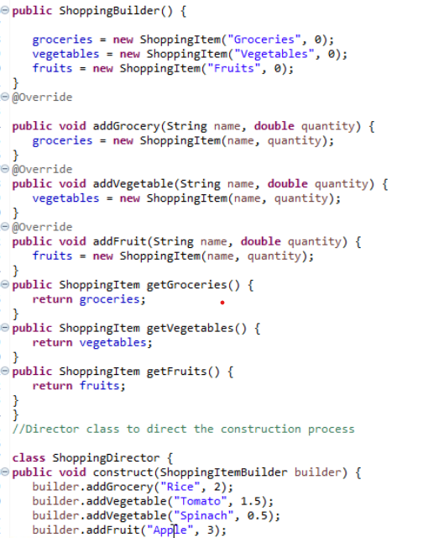

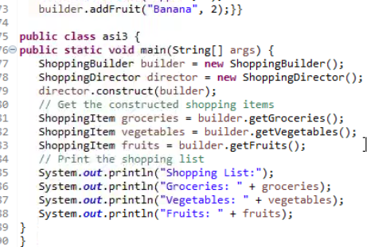

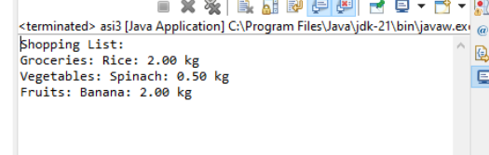

# Adapter Pattern

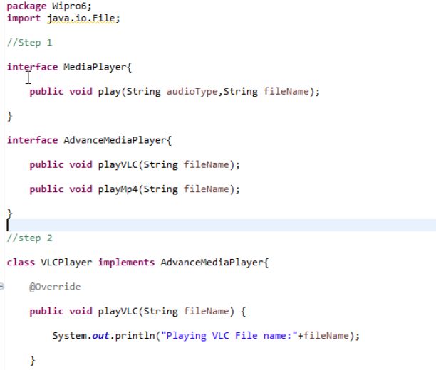

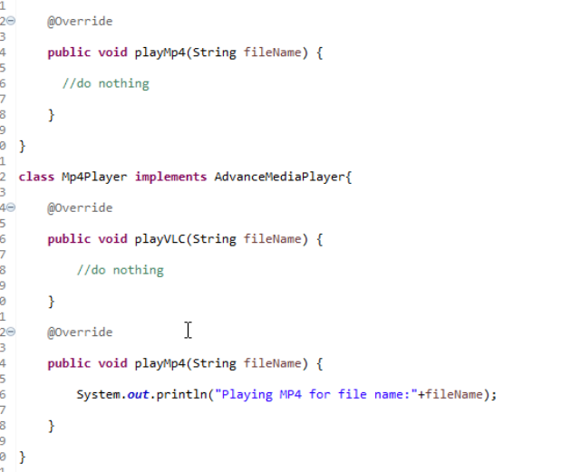

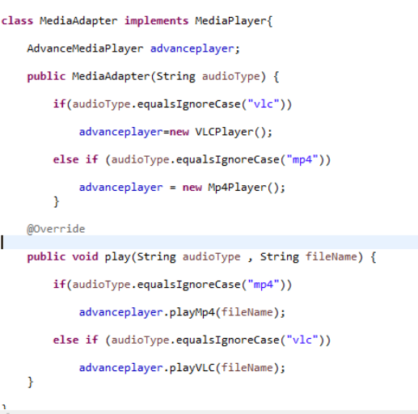

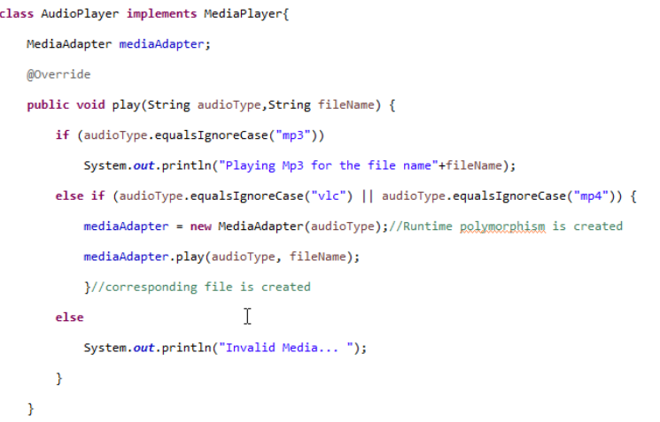

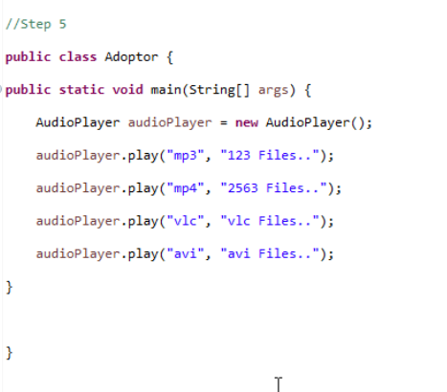

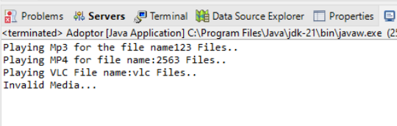

# JSP

Day7

# Scriptlet

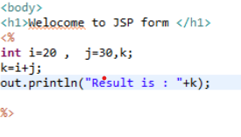

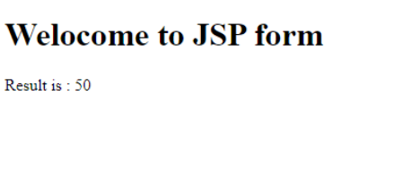

Script print numbers form 1 to 10

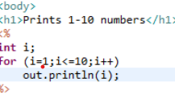

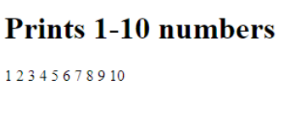

Declarative tags

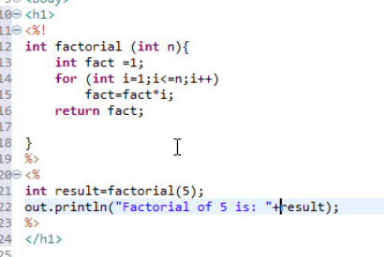

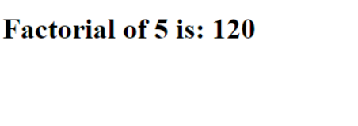

Expression Tag

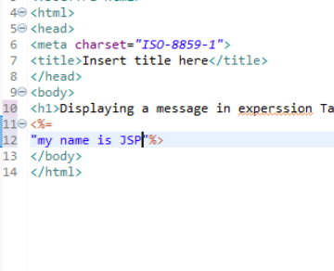

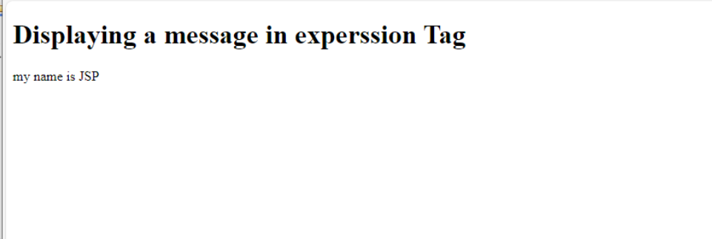

Displaying value of a variable using expression tag

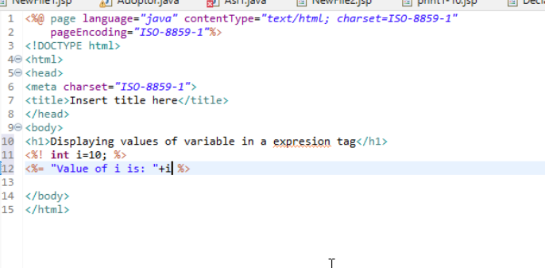

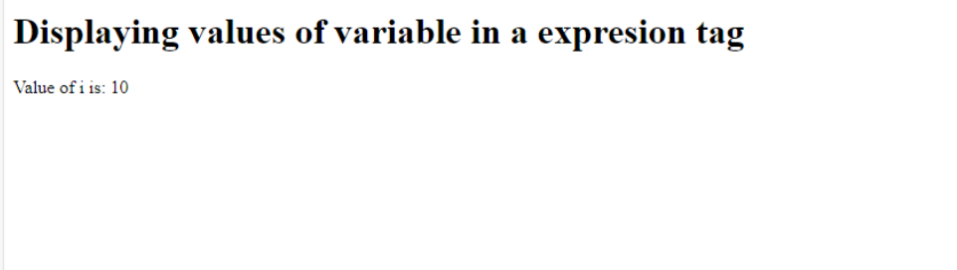

Request Implicit Object

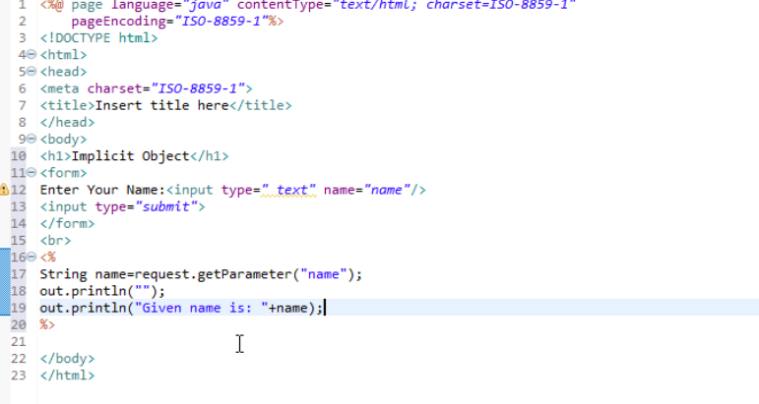

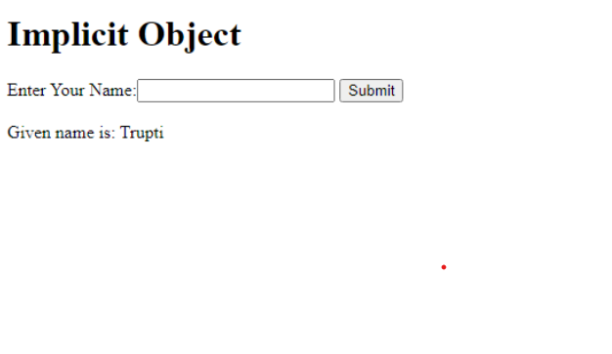

### **Even or odd**

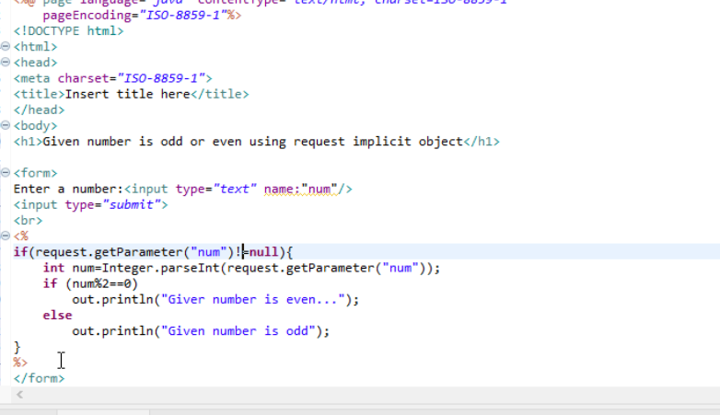

## 

Response implicit object

Response.html

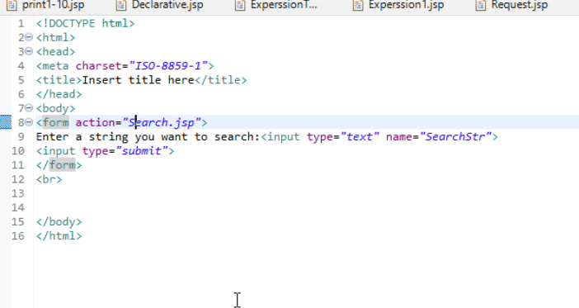

Search.jsp

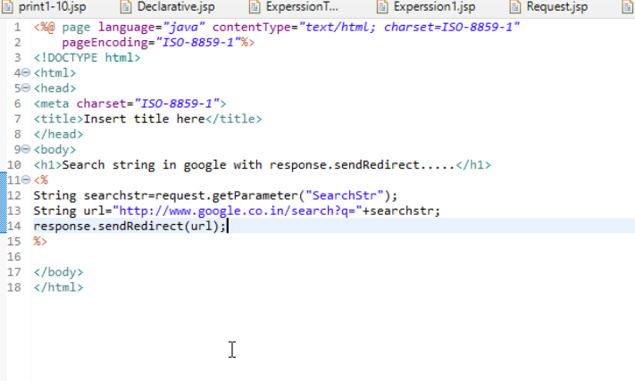

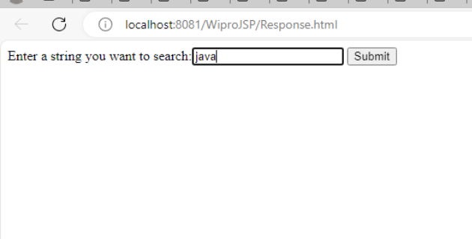

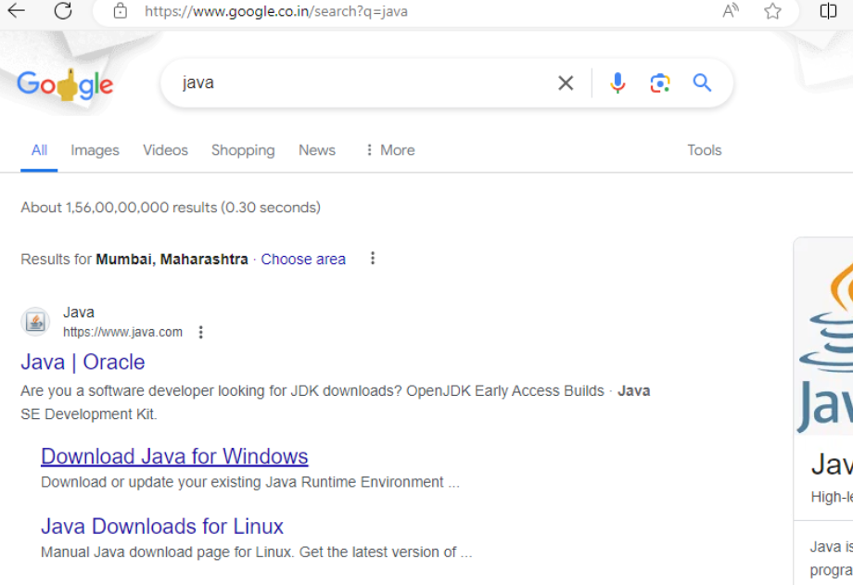

Page directive

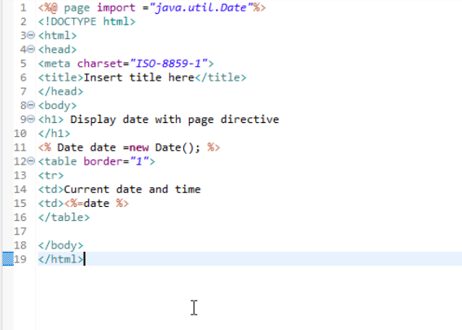

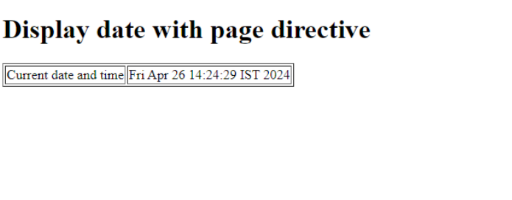

Include Directive

Include.html

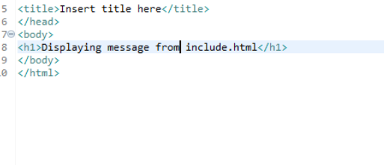

IncludeDirective.jsp

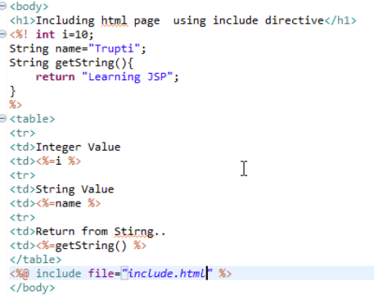

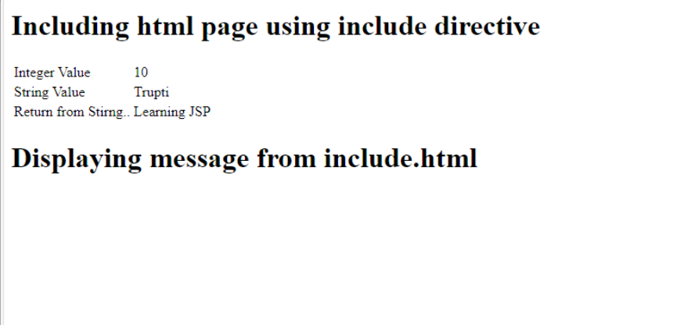

Include Action tag

IncludeAction.jsp

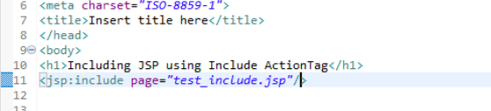

Test_include.jsp

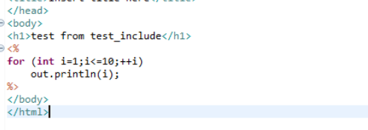

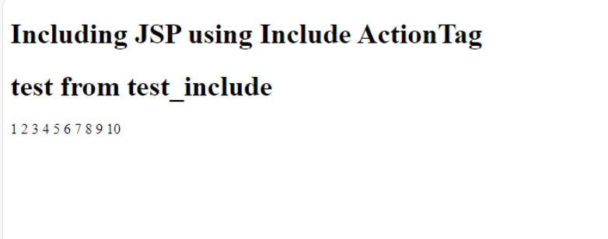

### **Interact with Java code using useBean**

testBean.jsp

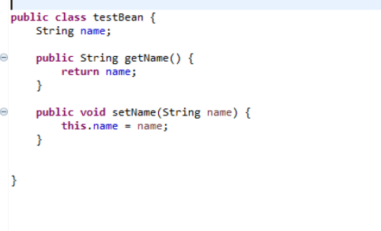

TestBean.jsp

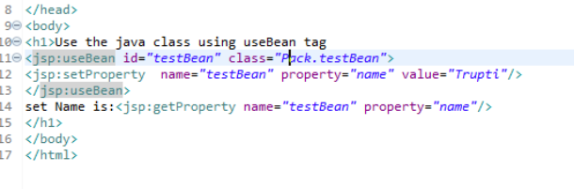

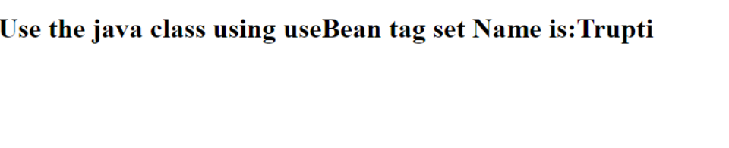

# Assingments of JSP

1. Write a JSP program to check given number is factorial of not.

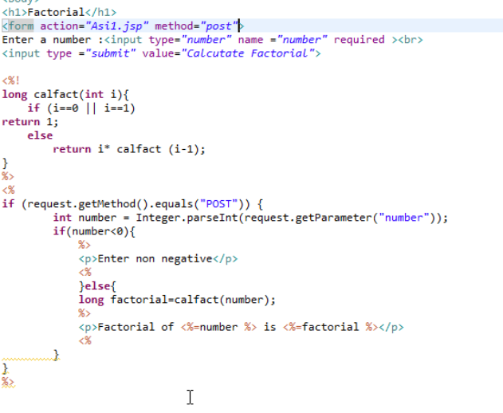

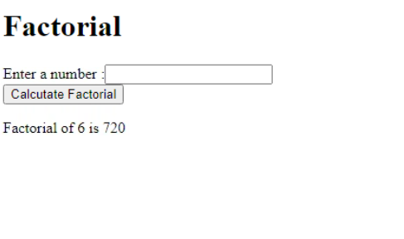

1. Write a JSP program to generate n fibonacci numbers.
2. 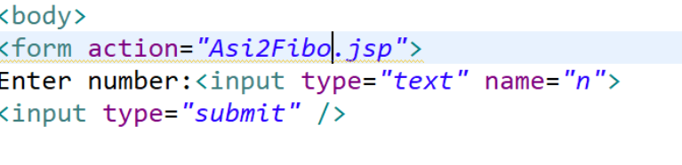

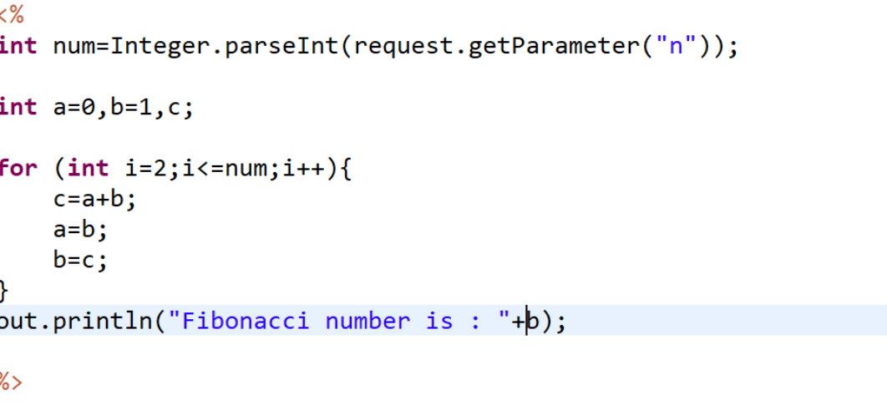

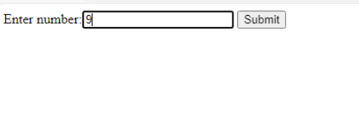

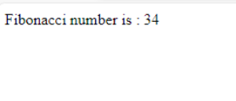

3.Write a program to check the given number is prime or not.

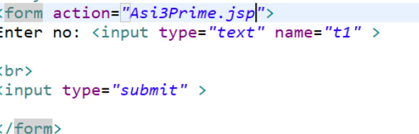

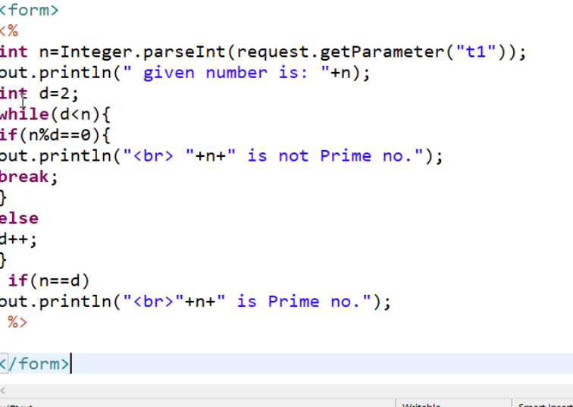

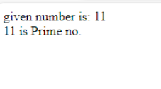

4. Write a program to get the sum of n numbers.

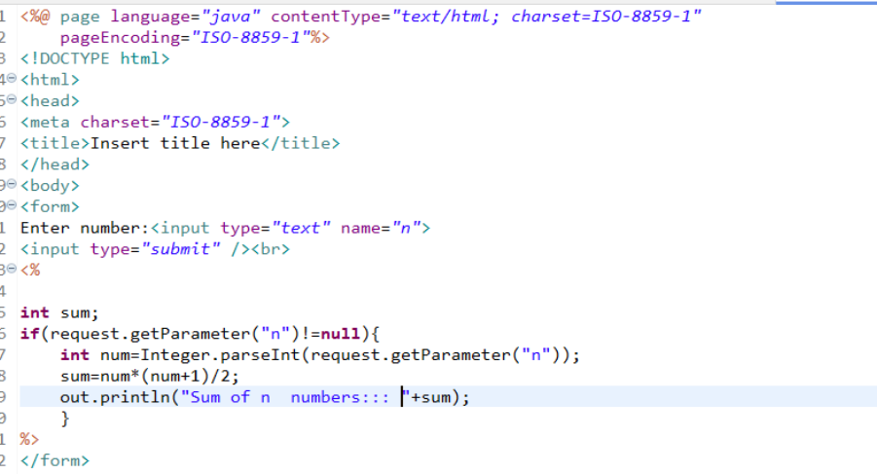

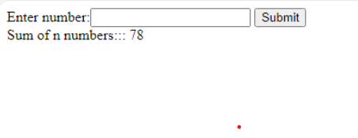

5. Write a program to take a number and print sum of its number.

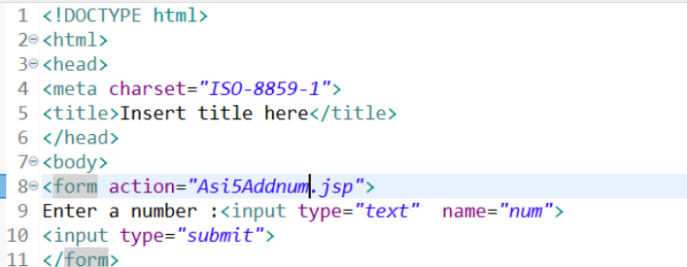

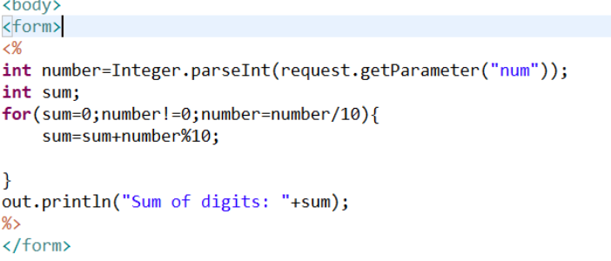

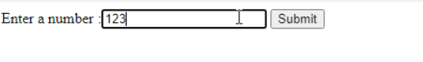

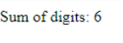

6. Write a program to take a number and print the reverse of a number. 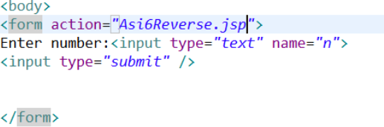

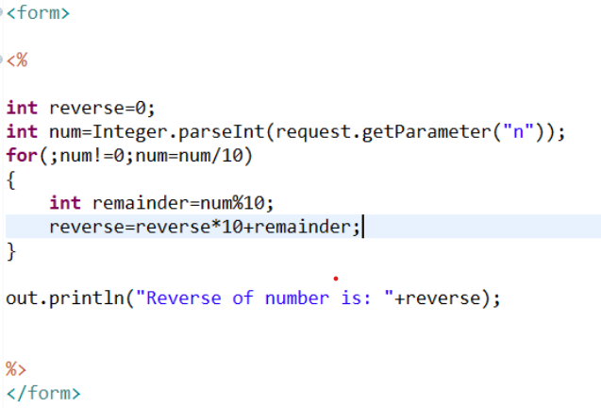

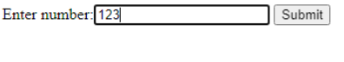

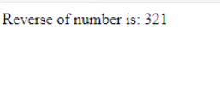

7. Write a program to display any domain data in a table. Table should have atleast 5 rows.

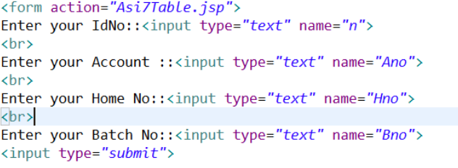

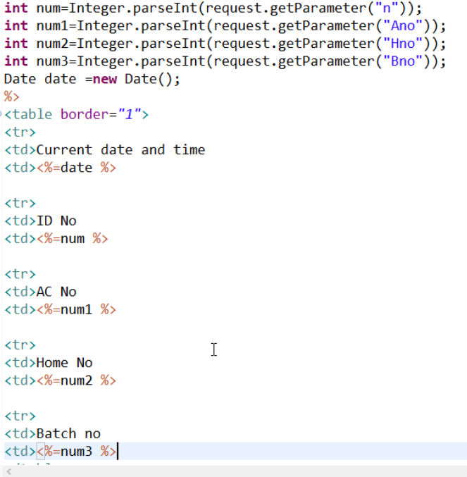

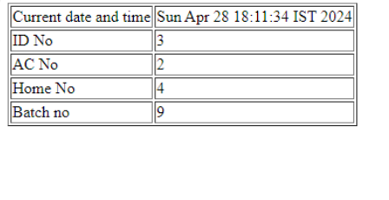

8. Enter Employee data like id, name, dept and designation. If all the fields are entered then display as Valid employee and saved in databas else display a message as "All the data is not given".

9. Generate random numbers and display in jsp.

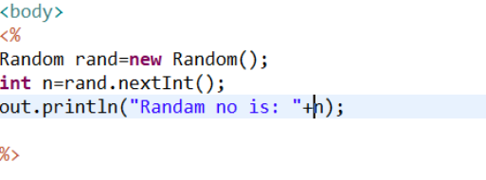

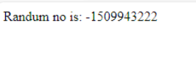

10. Perform one of the above using include directive and one using inlude action.

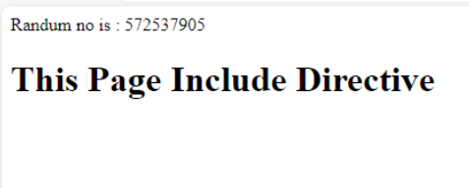

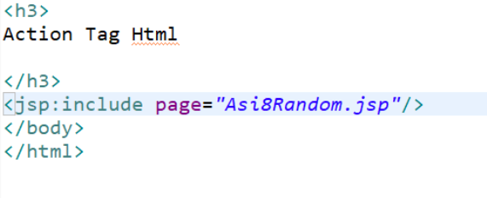

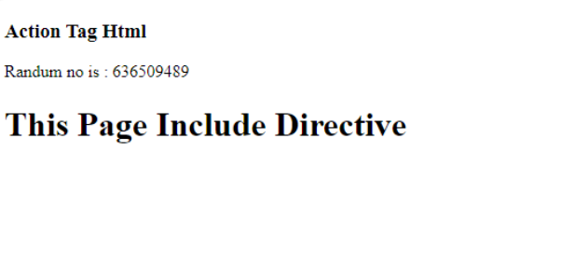

# Proxy Pattern

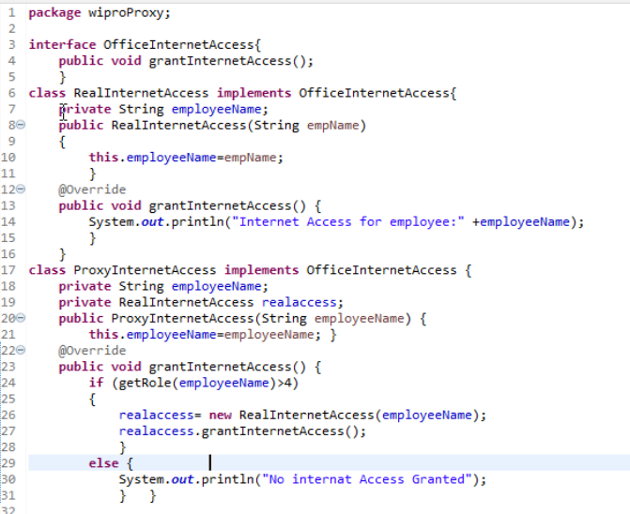

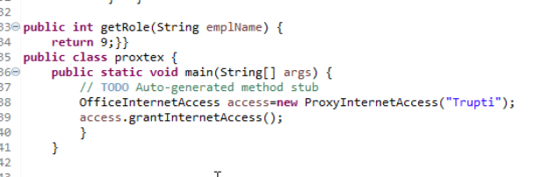

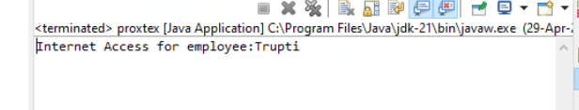

# Spring Core

### **Displaying the bean info**

Step 1 : Add these dependencies in pom.xml

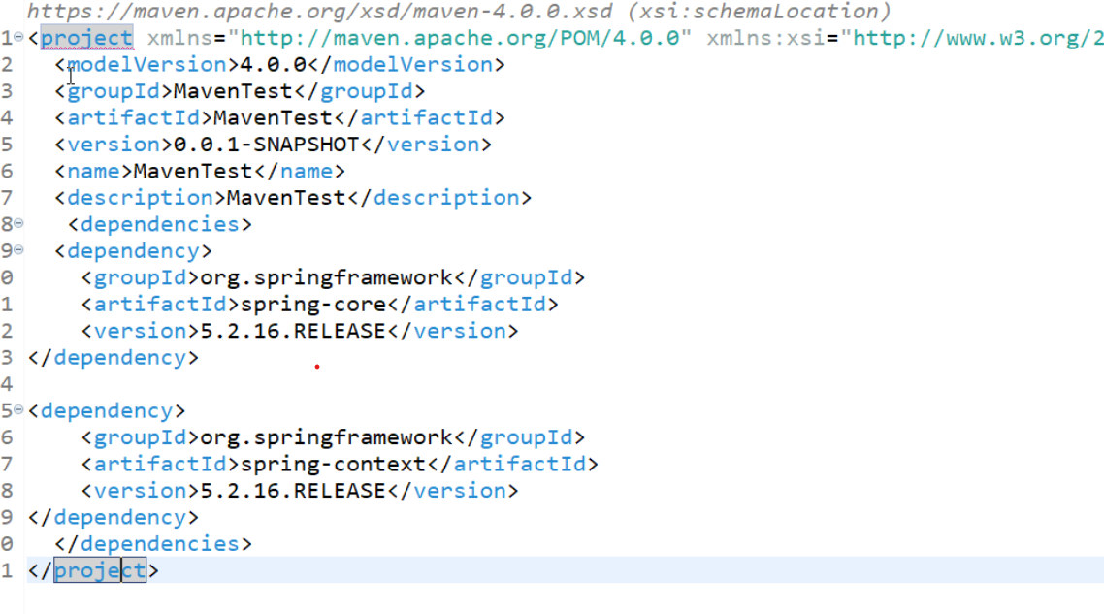

Step 2:  Create a Pojo / Bean class. Employee1.java

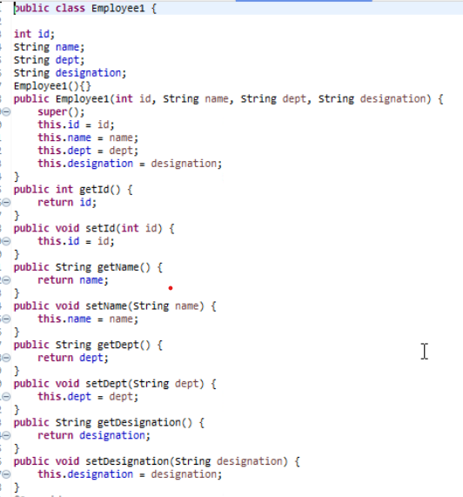

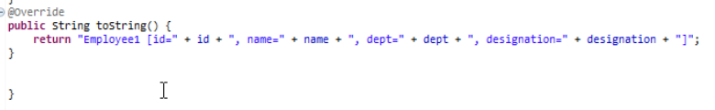

Step 3 : Create an xml src\main\resources named **display_BeanInfo_HelloBean.xml** file.

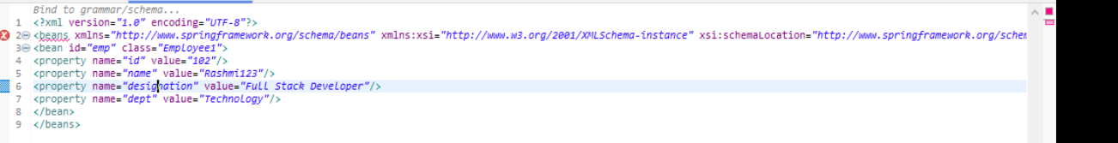

Step 4 : Create a display_Bean_Info.java

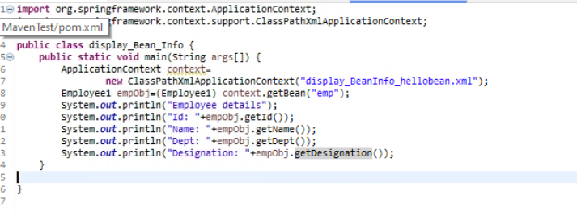

Step 5 : Run Display_Bean_Info.java → Run As → Java Application

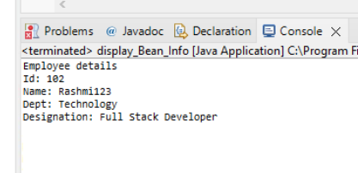

## Bean Init and destroy

Step1 : Create a Hello1.java pojo class

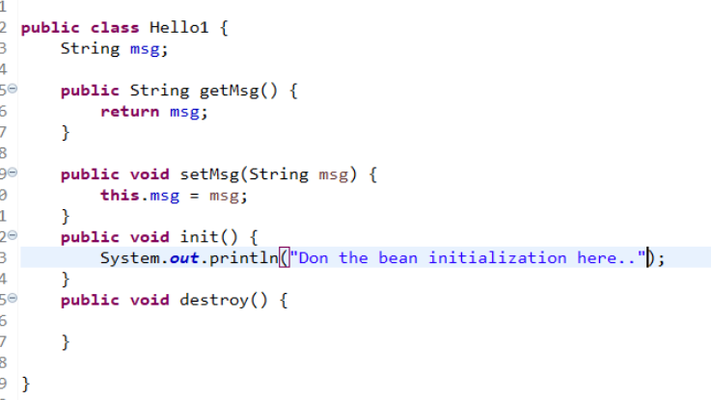

Step 2: Create a xml file named bean_init_Destroy.xml

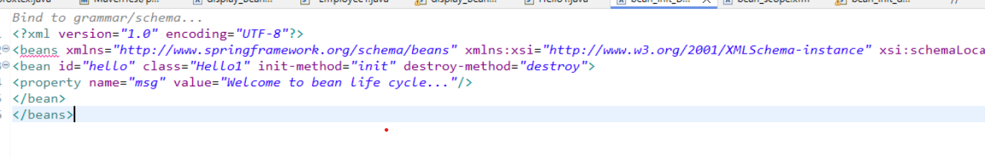

Step 3: Create a bean_init_destroy_client.java

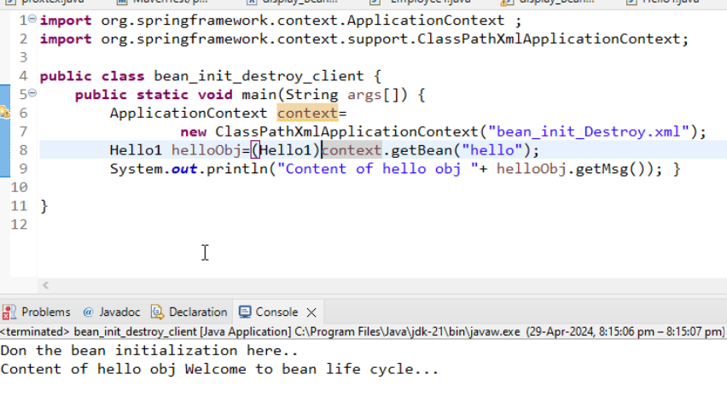

### **Bean Scope**

Step 1 : Create a Pojo named Hello1.java → It is already created in previous program.  You can make use of it.

Step 2: Create a xml file named bean_scope.xml

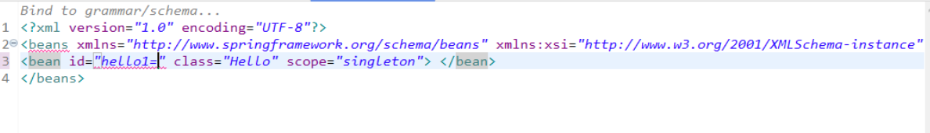

Step 3 : Create a bean_scope_test.java

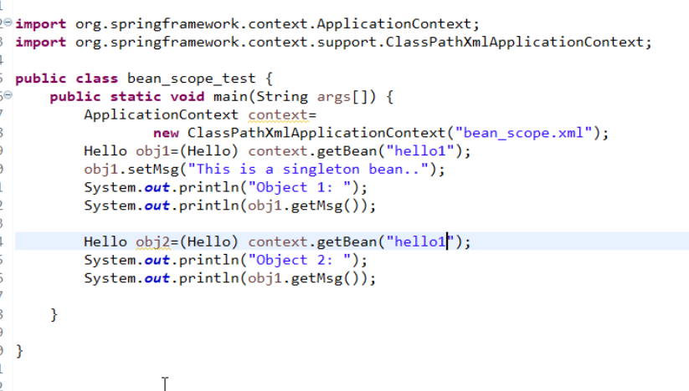

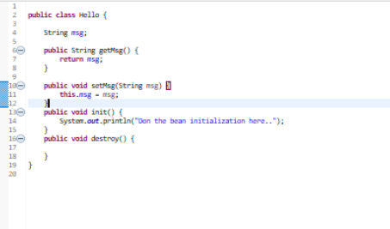

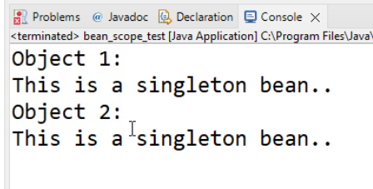

### **Setter based dependency Injection**

Step 1 : Create Employee1 under the package SetterBasedDI

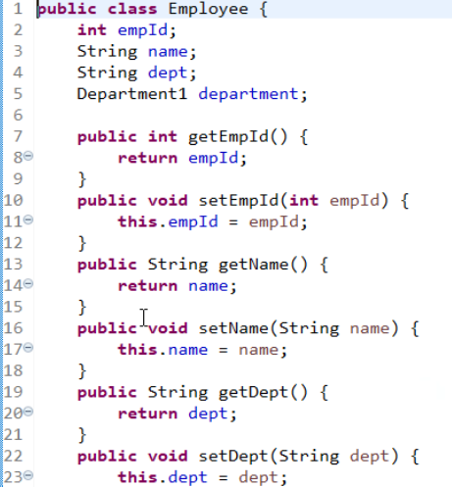

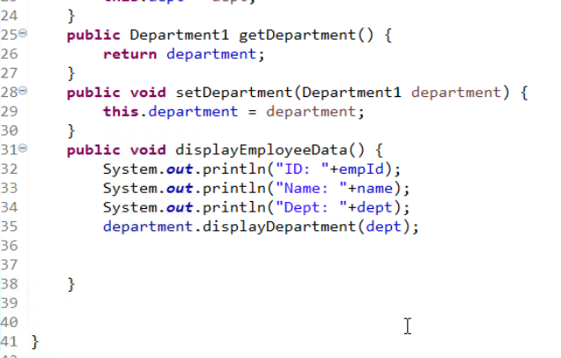

Step 2: Create Deparatment1.java under SetterBasedDI package.

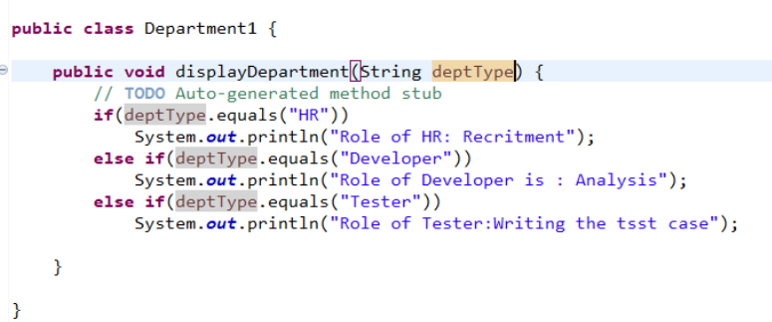

Step 3 : Create xml named setter_based_DI.xml under src\main\resources

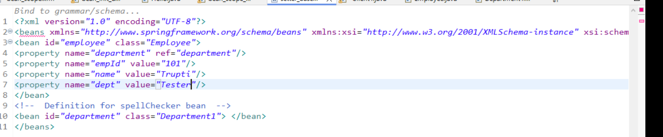

Step 4 : Create Client1.java under SetterBasedDI package.

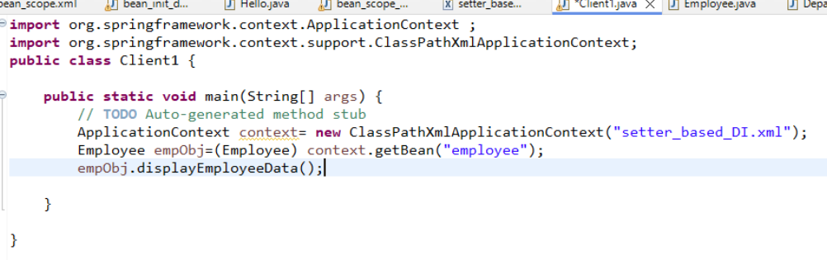

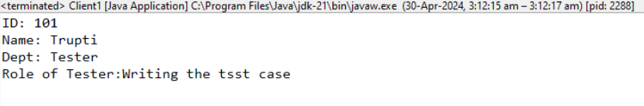

# Day 9

## **Spring MVC**

### **Display a greeting**

Step 1 : Create a Controller named MyController as write the below given code.

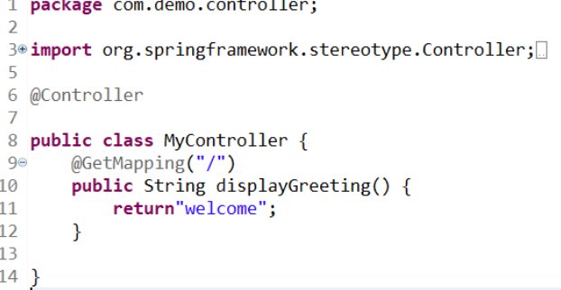

Step 2 : Add prefix and suffix in application.properties

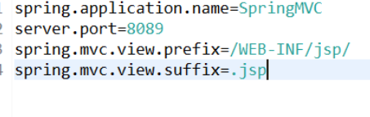

Step 3 : create folder under src\main as src\main\webapp\WEB_INF\jsp

Step 4 : Create welcome.jsp and write the following content

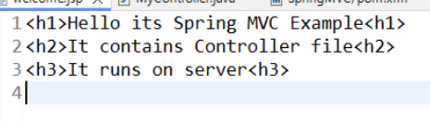

Output:::

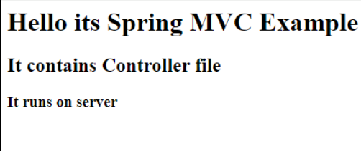

### **Login Validation**

Step 1 : Add the following code to MyController.java

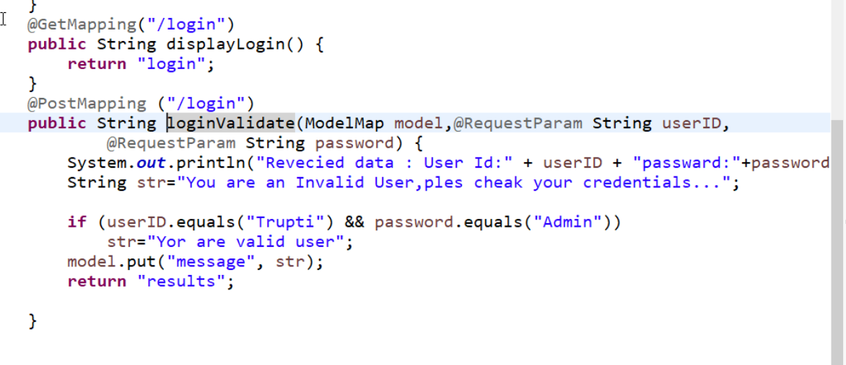

Step 2 : Create login.jsp under \WEB-INF\jsp location.

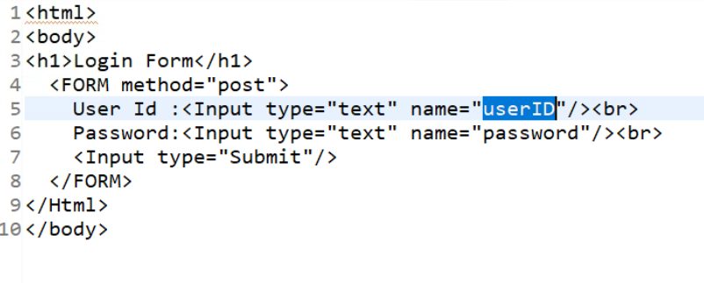

Step 3 : create results.jsp

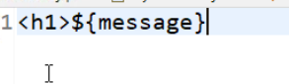

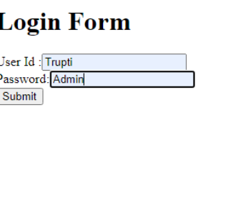

Step 4 : Run the program in the browser with the url

Step 5 : Enter data and click on submit button

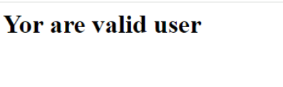

Day10

Spring REST

CRUD operations..

# 

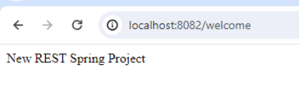

### Login Validation with RequestParam

In the controller ad the following code:

### 

### 

### 

### CRUD Operation:

Step 1 : Create a POJO class under com.demo.data.

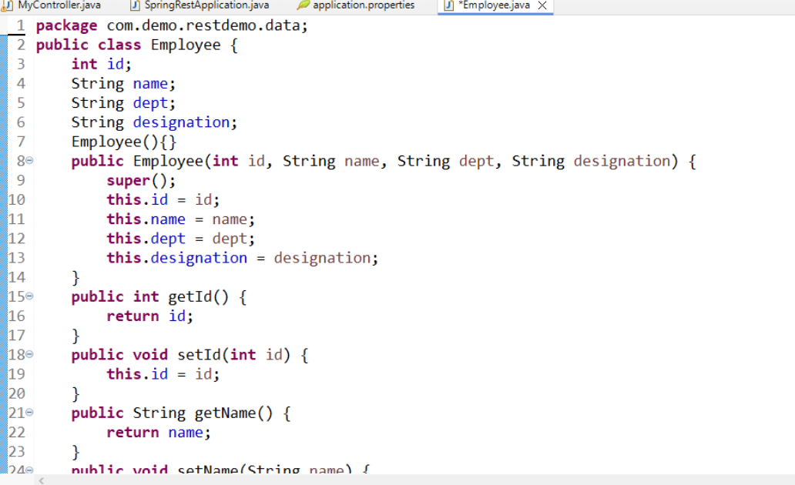

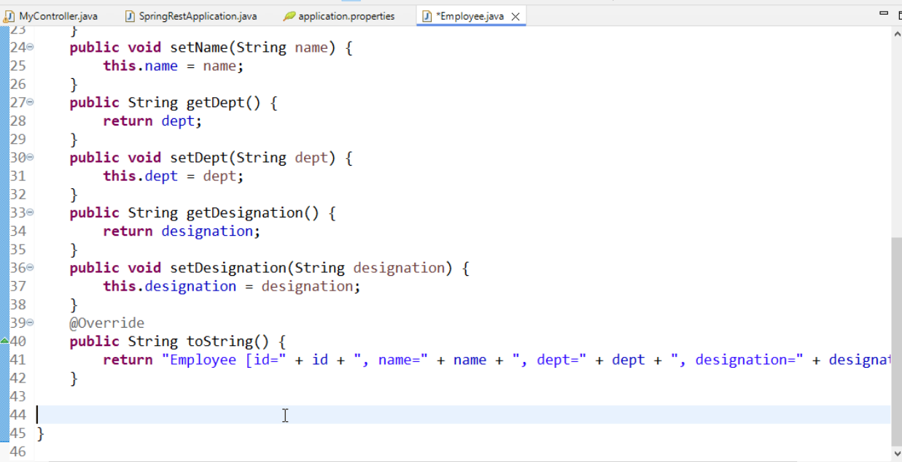

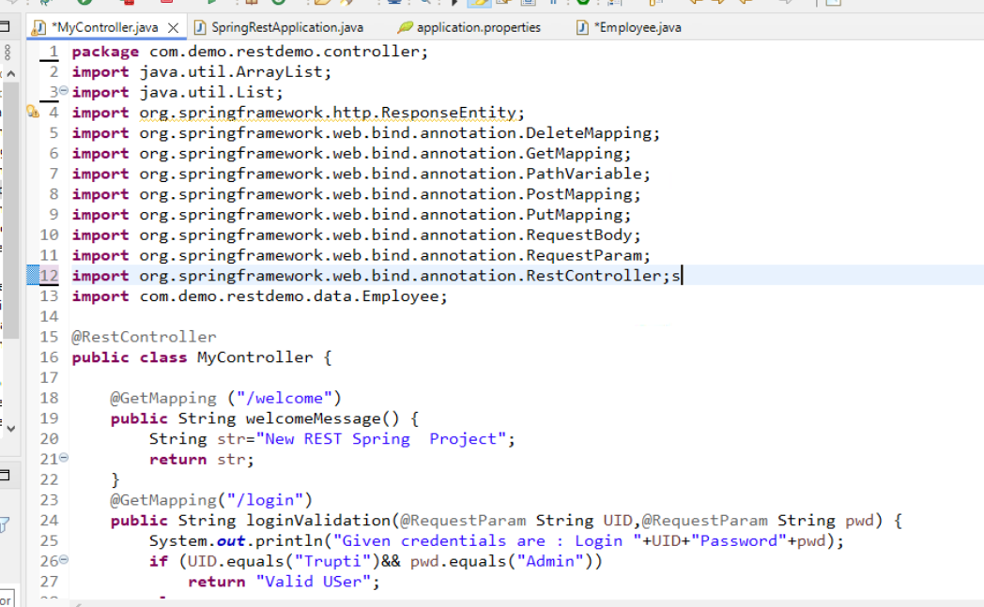

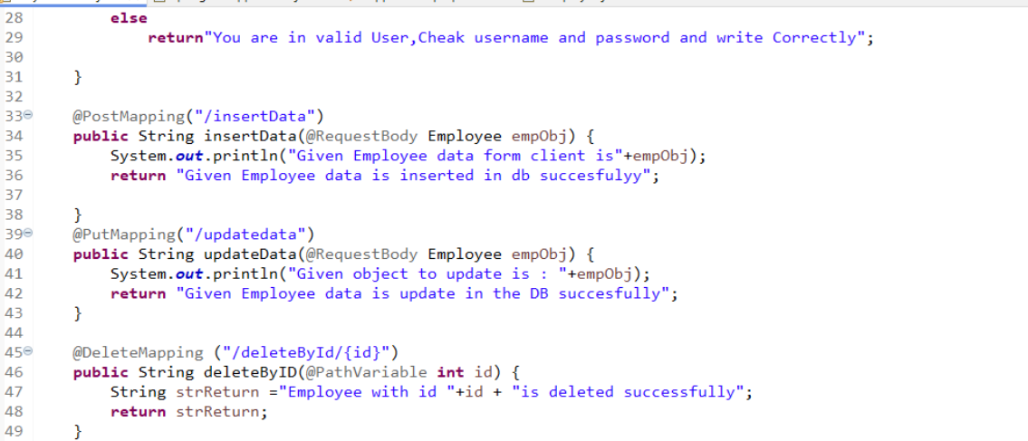s

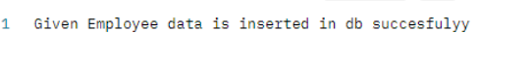

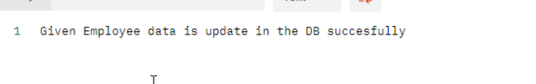



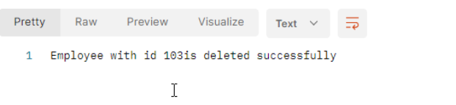

### Step 2 : Add the following in MyController.java

### 

### 

## Assignemnt::

### create a URL named findByID/<id of the employee> --> Return the record given as id in the url. For Exmaple : http://localhost:8091/findByID/102

### then record with employee id 102 should be displayed.

### *

### 

# Day11

Step:1

Client.java

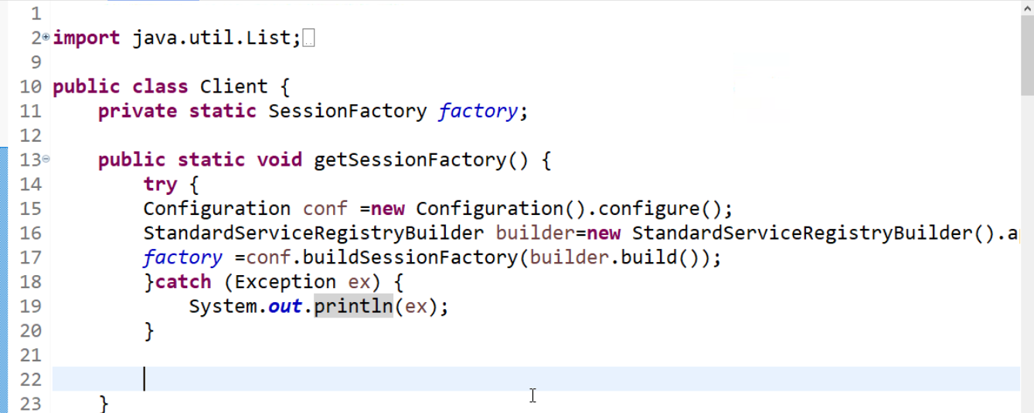

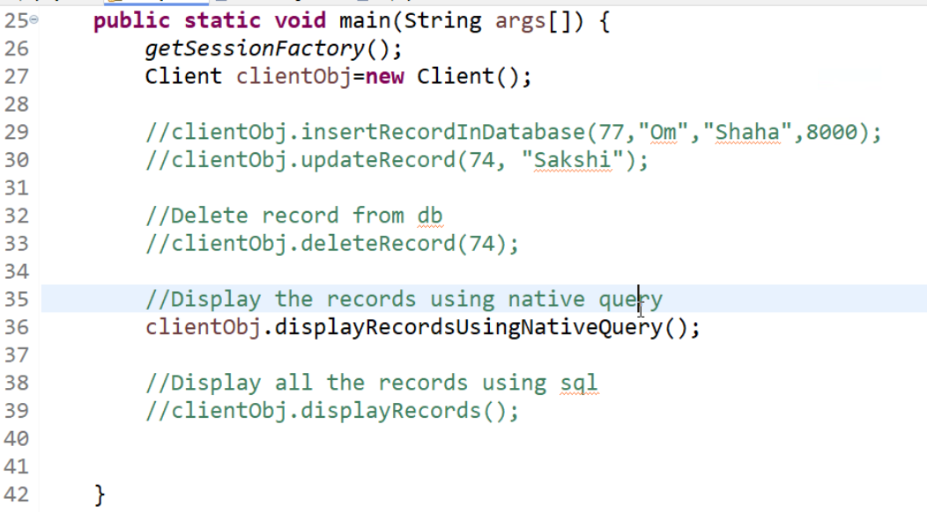

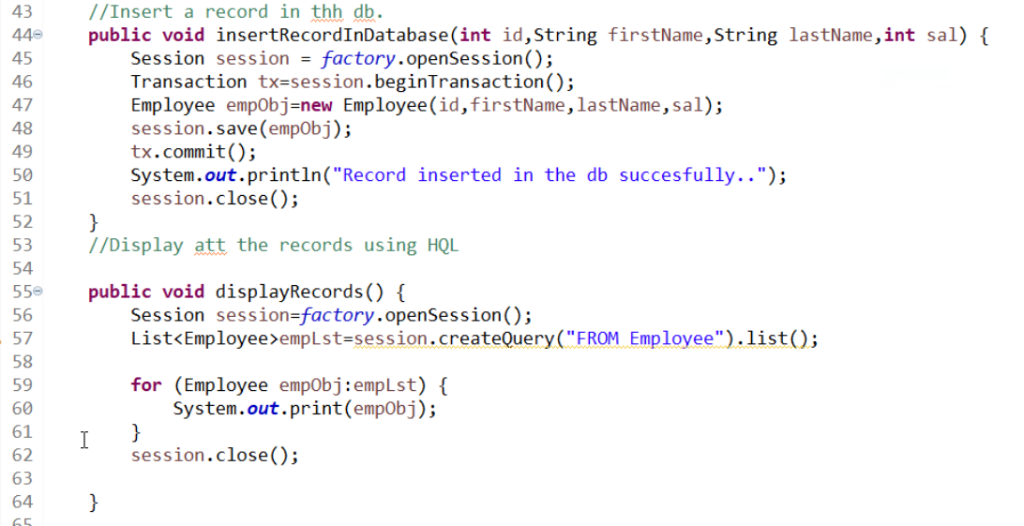

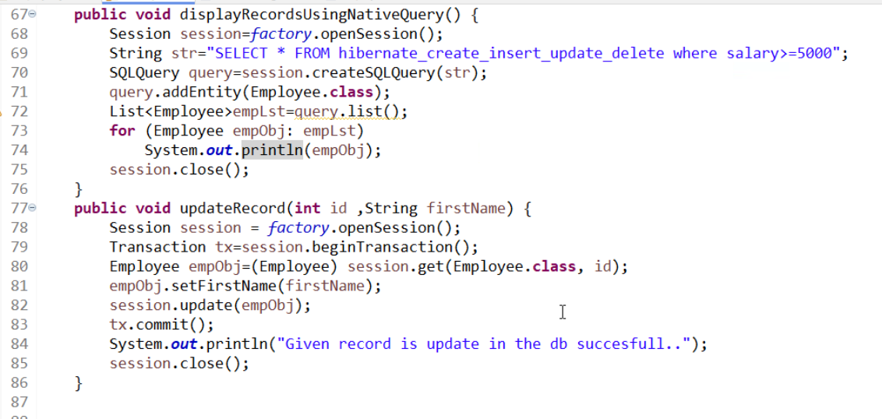

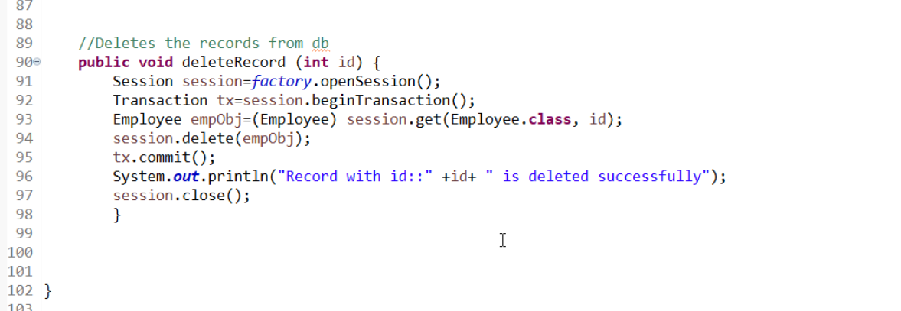

Step 2 : Create Employee POJO class

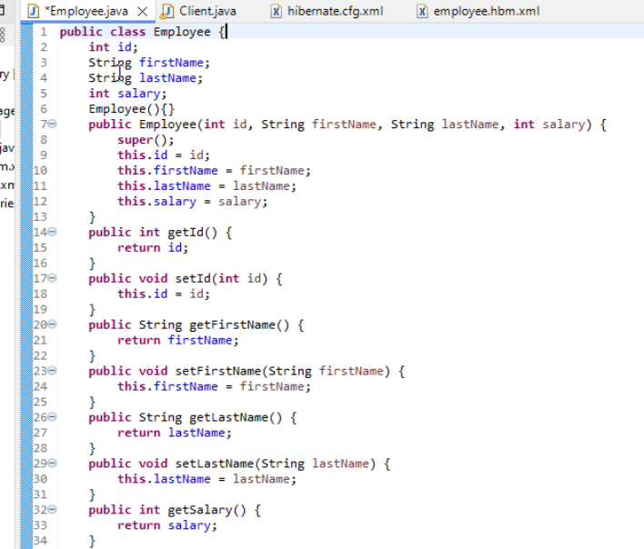

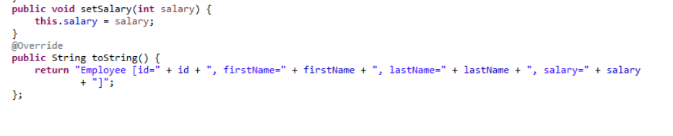

Step 3 : Create employee.hbm.xml file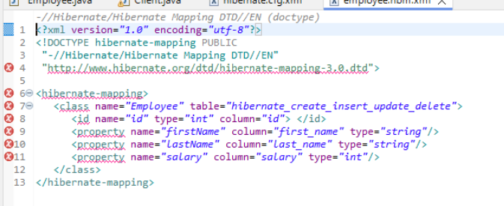

Step 4 : Create hibernate.cfg.xml

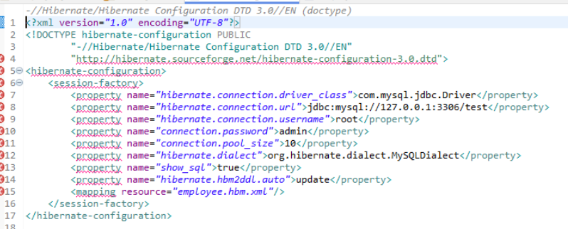

Insert Data into Database

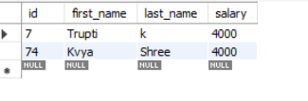

Update records from Database



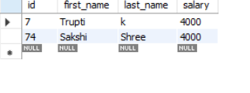

Delete record from data base

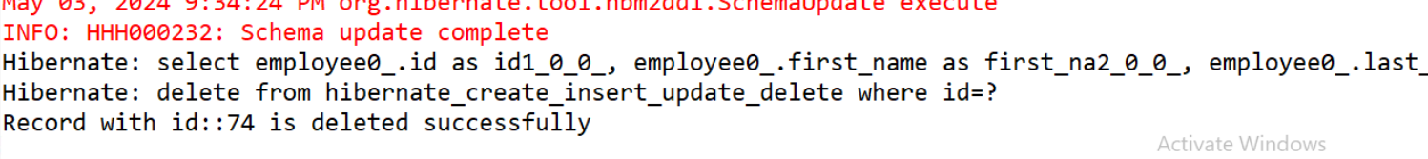

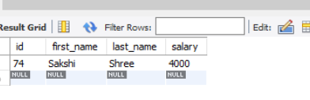

Display records using Native

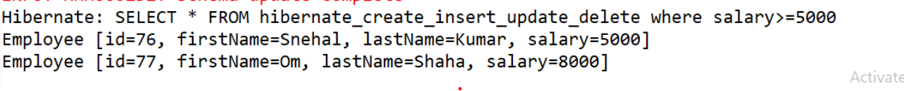

**A**

### 

# Day-12

# Unit Testing of Spring Boot Application

Step 1 : Create Spring Boot application with web, actuator and dev-tools.

Step 2 : Create MyController under the main project with the following code:

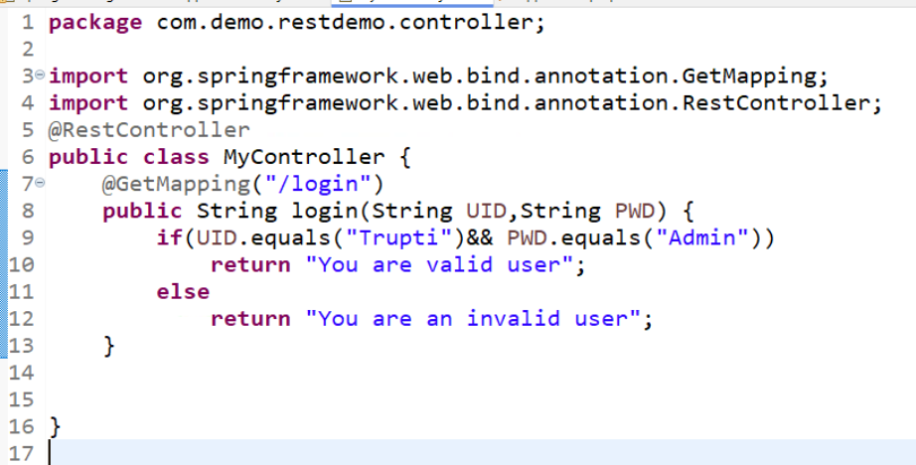

Step 3 : Write the following code in SpringUnitIntegratonTestingTests.java.  This file is under src\main\test

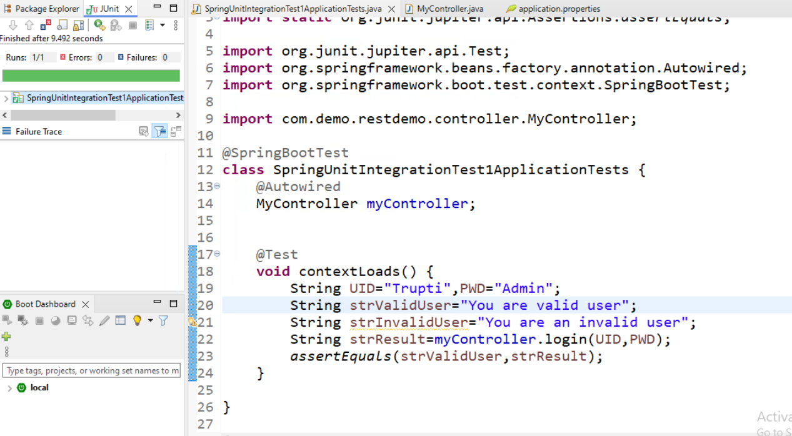

### **CRUD operations in Spring jPA**

Step 1 : Create a Spring Boot Project

Step 2 : Add the db properties in application.properties

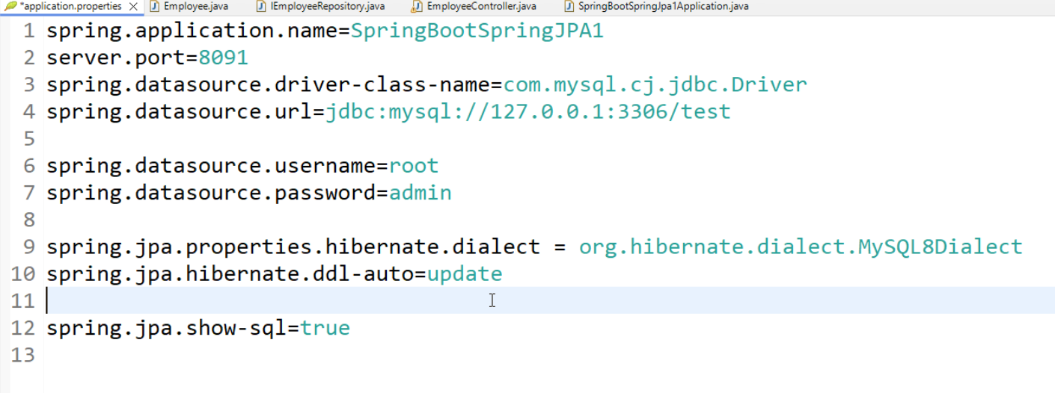

Step 3; Create a Employee data / pojo/beans class

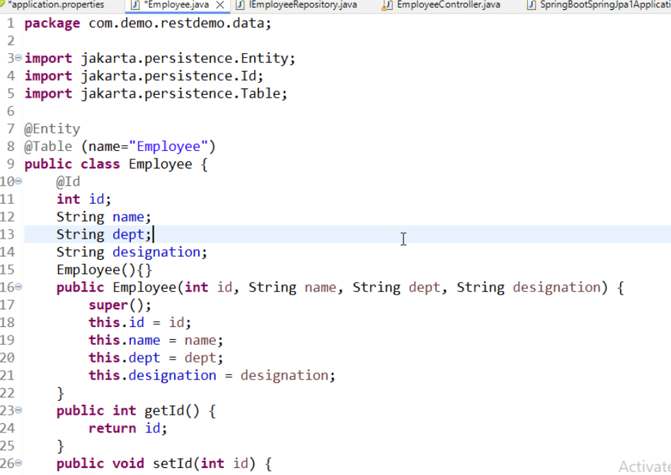

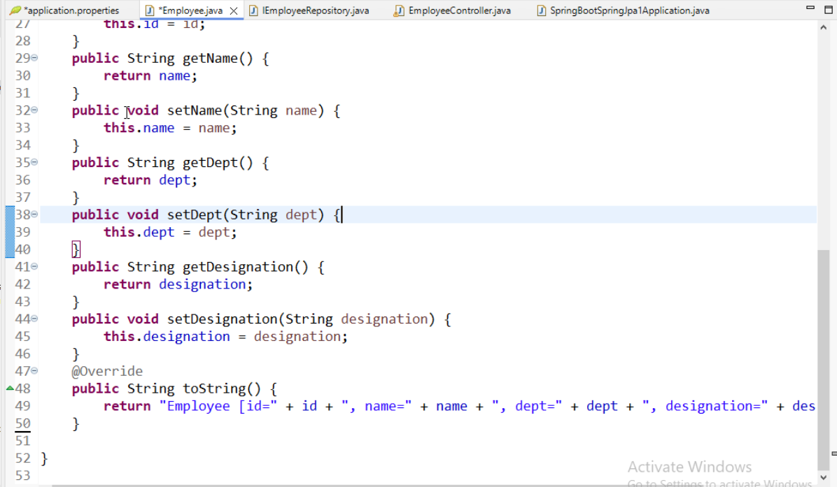

Step 4 : Create a IEmployeeRepository interface with the following code.

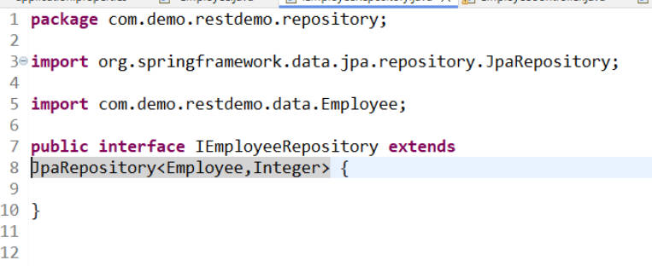

Step 5 : Create a Controller with the following code:

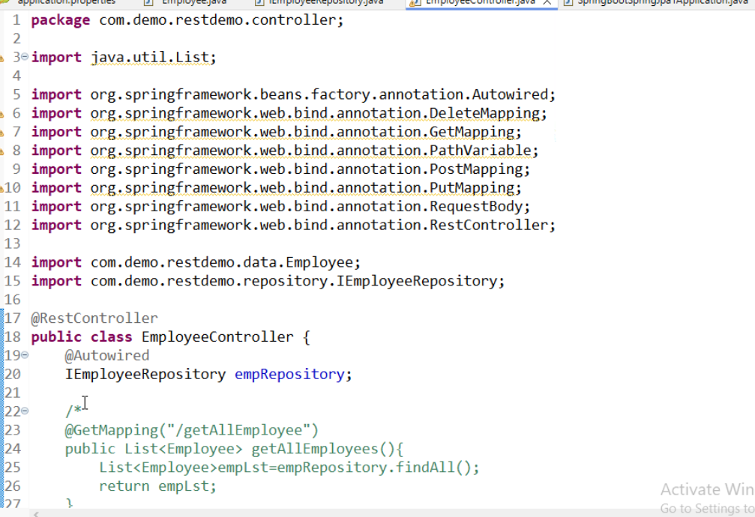

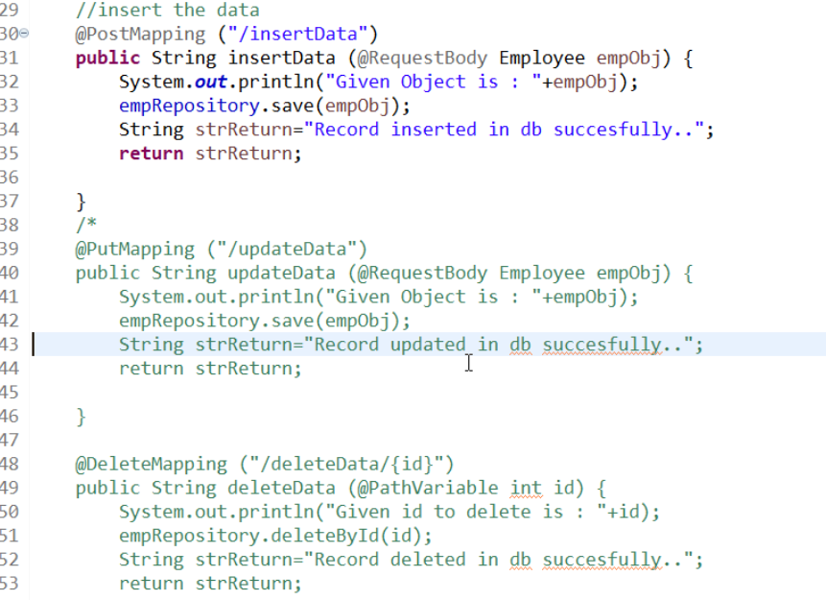

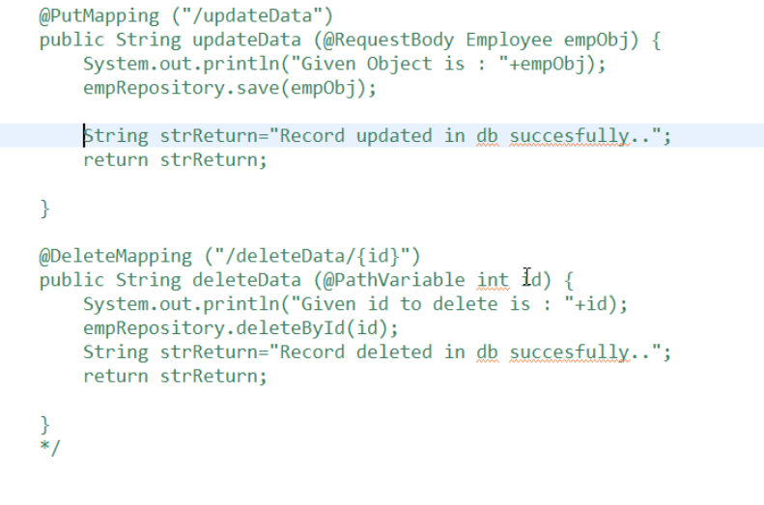

POST - Insert Data

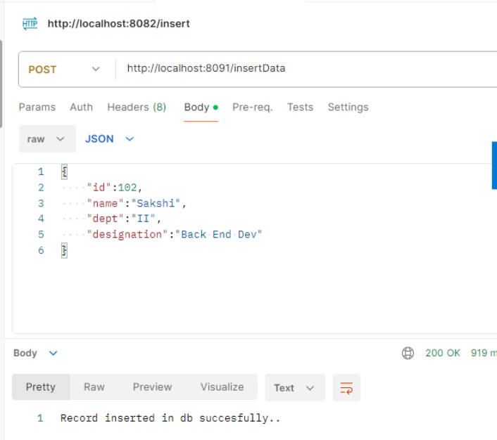

Delete Data:

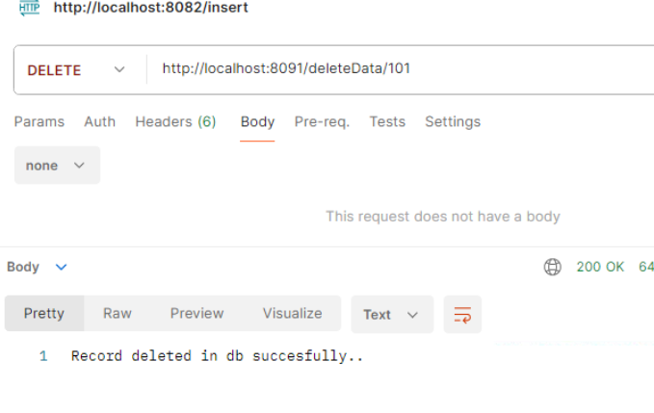

Update Data:

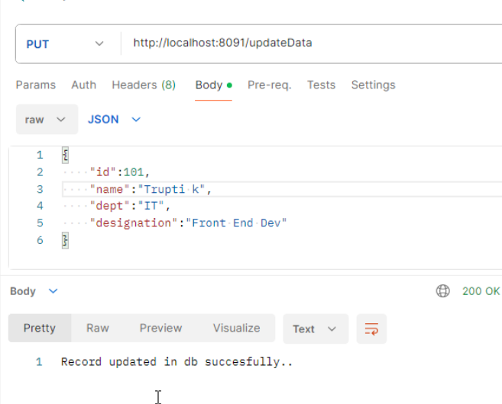

Get Data:

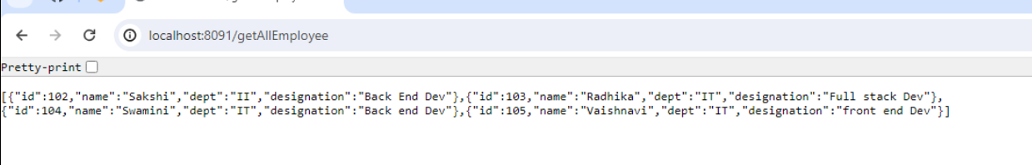

# Perform CRUD Operationso on Student table. Student table the following field (a) Student Id (b) Name (c)Stream (d) Total percentage.

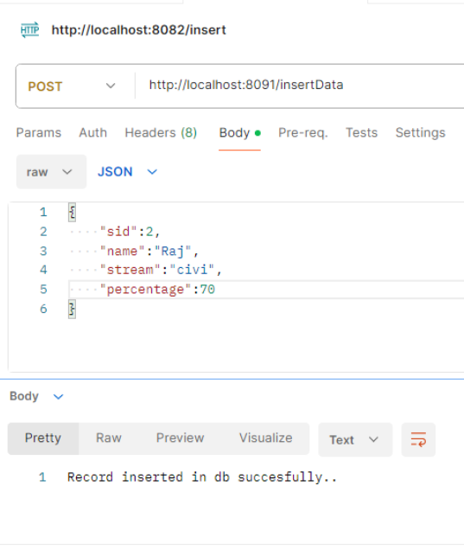

Update

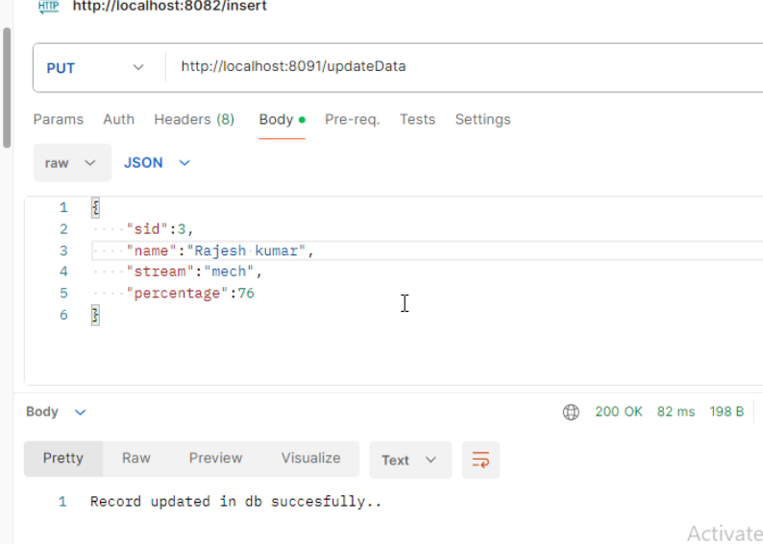

Delete

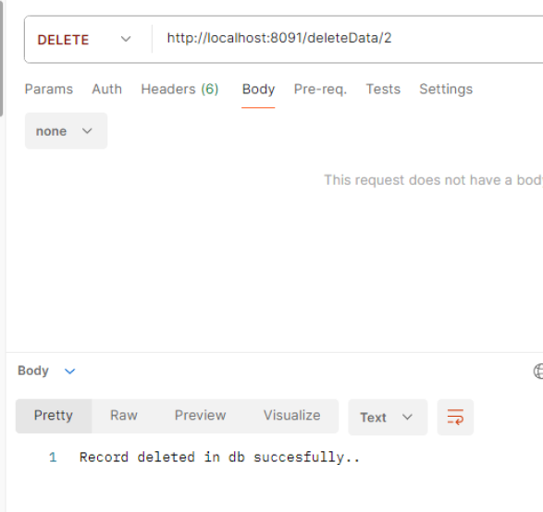

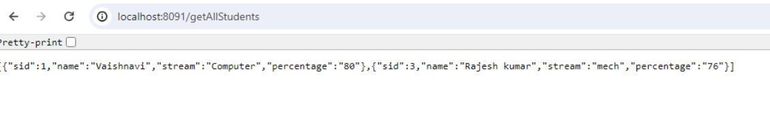

# Observer Pattern

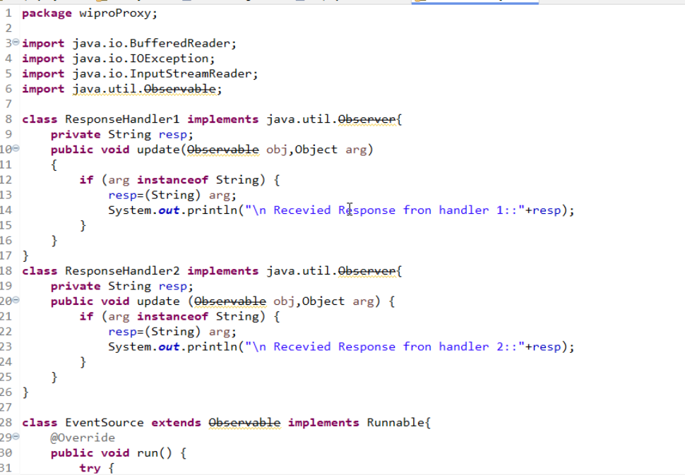

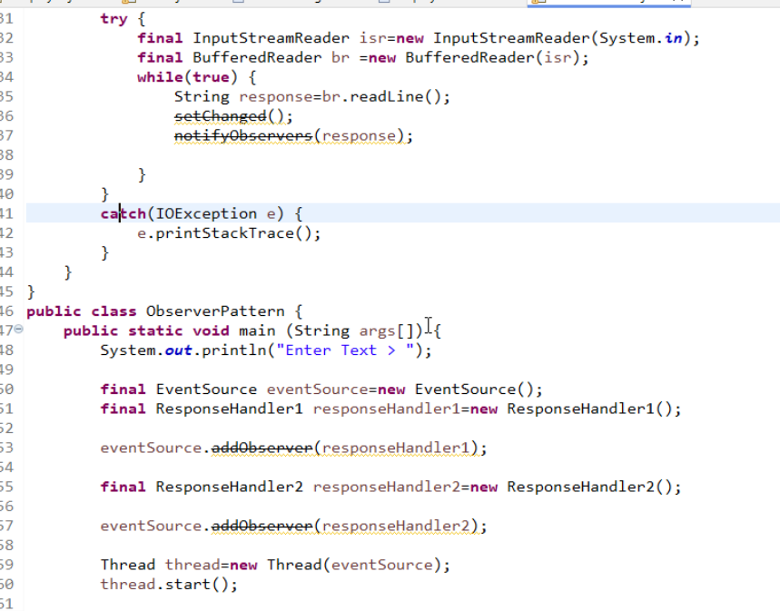

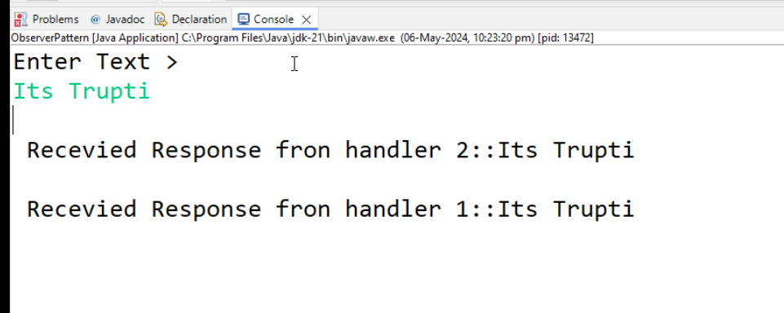

# Day-13

# Strategy Pattern

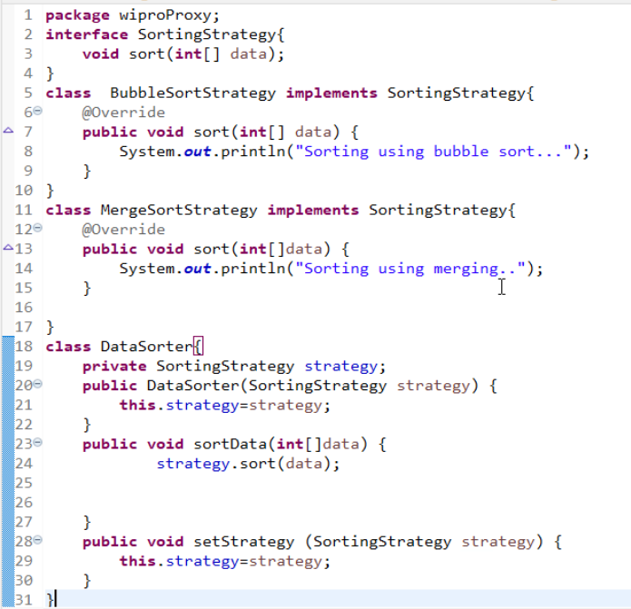

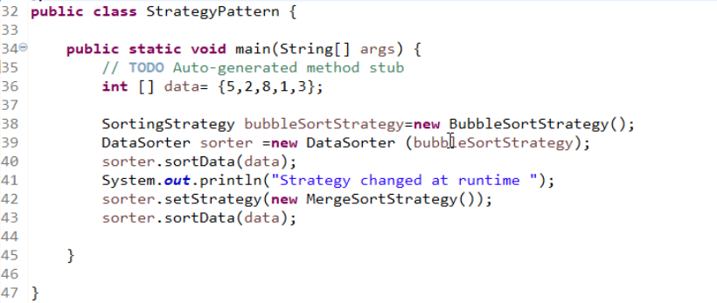

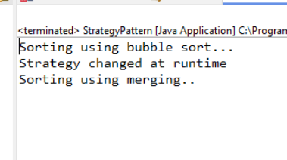

MMMMMM

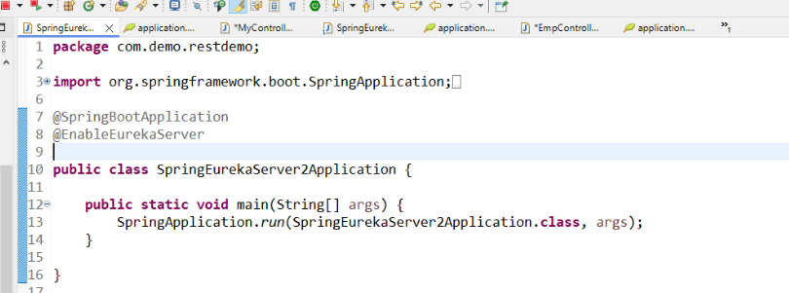

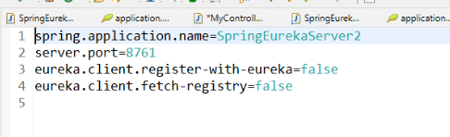

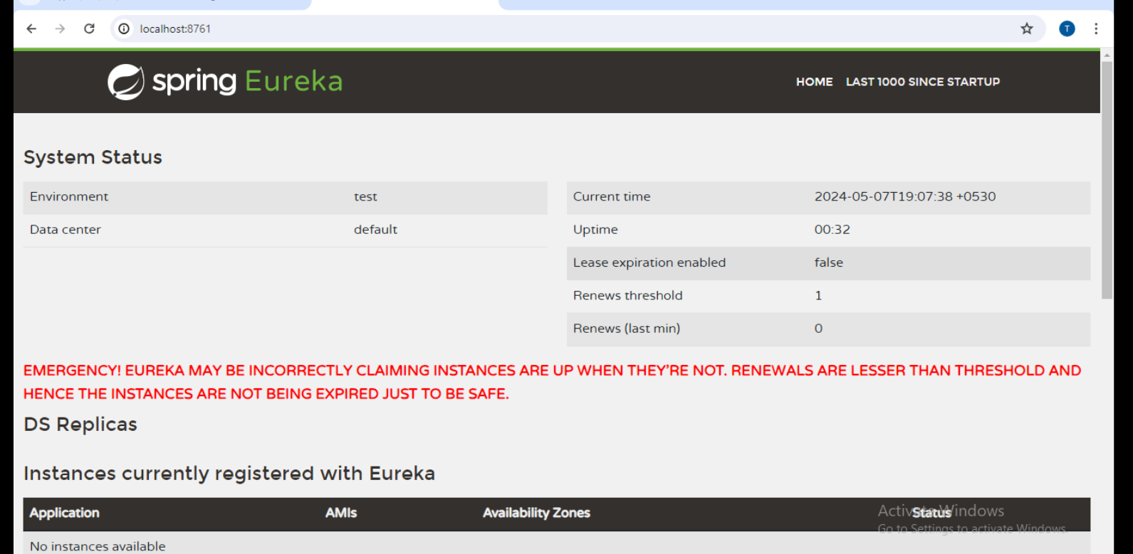

Create a client which provides employee data.  This is a eureka client.

Step1 : Create a spring boot project

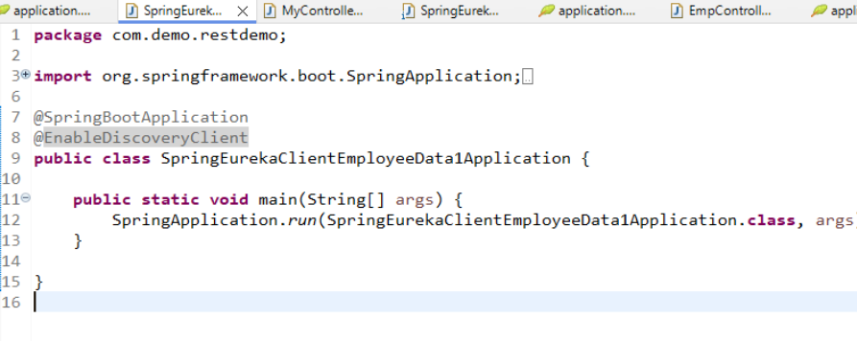

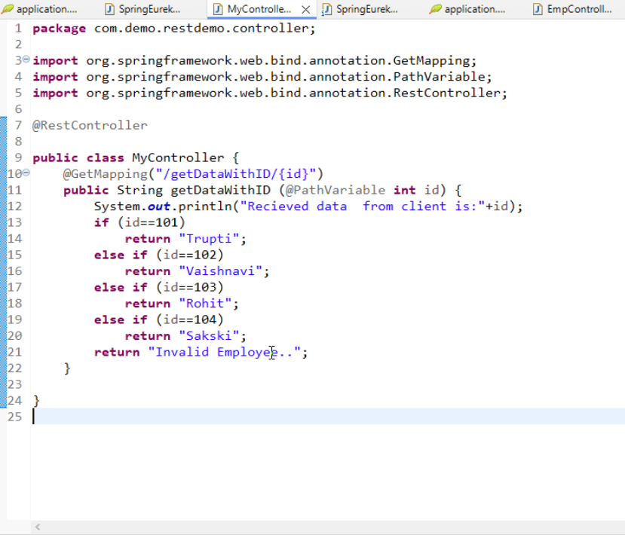

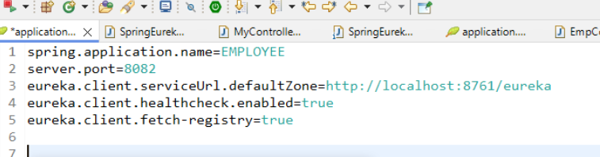

Create another Spring Boot Application for accessing Employee details.

Step 1 : Create spring boot application

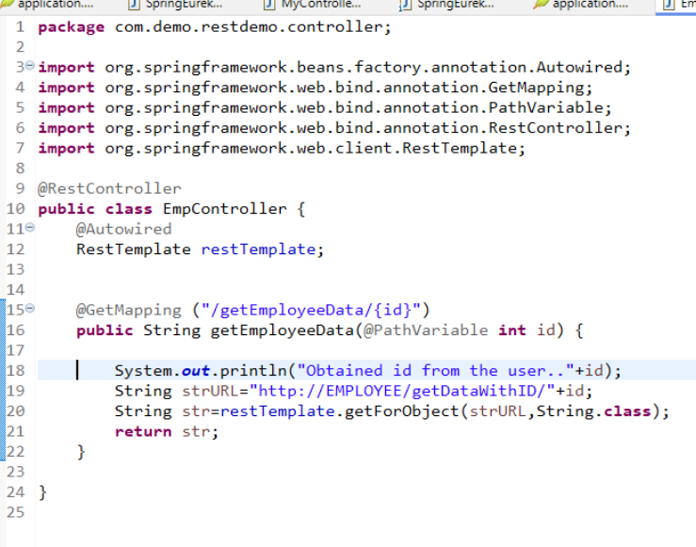

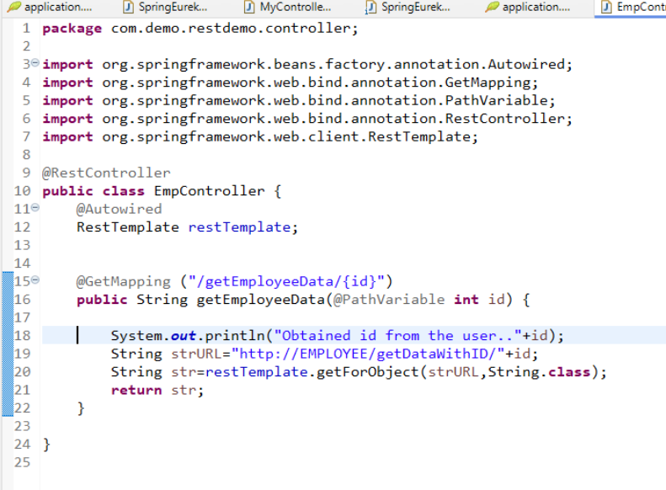

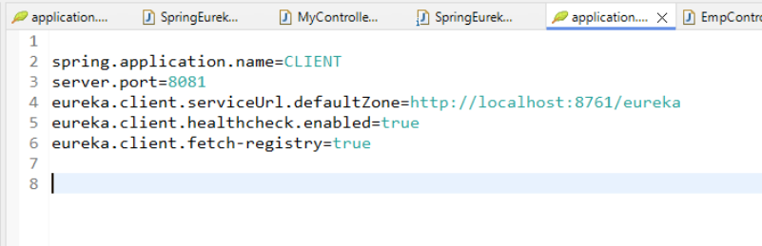

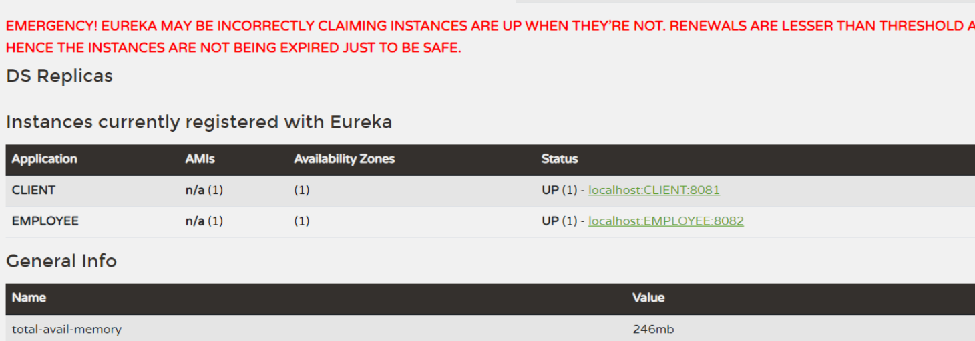

# Day-14

# MONO

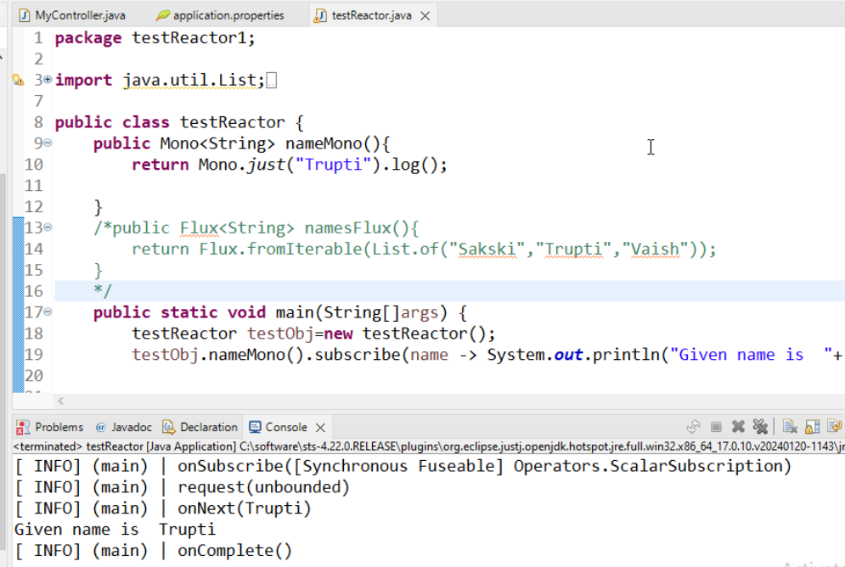

# Flux

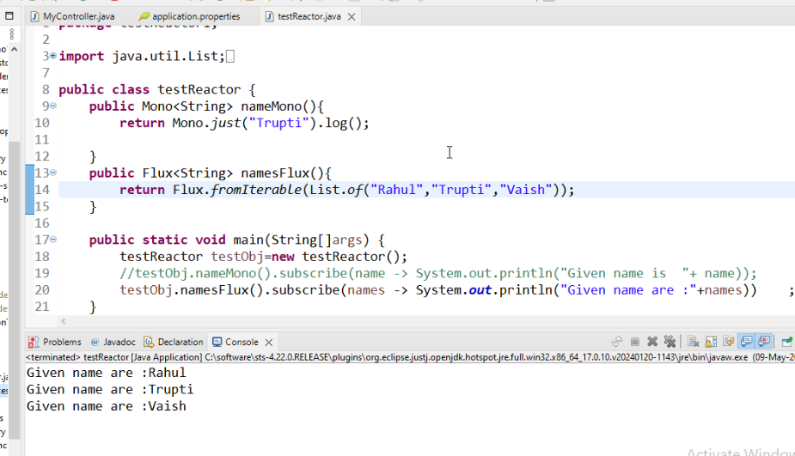

# Reactor with Spring

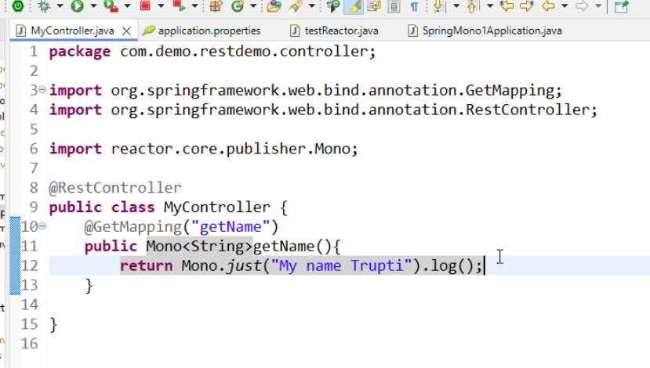

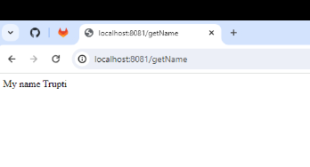

# Day—16

### **Docker pull**

Pulls the image fom registry to the docker machine or docker server.

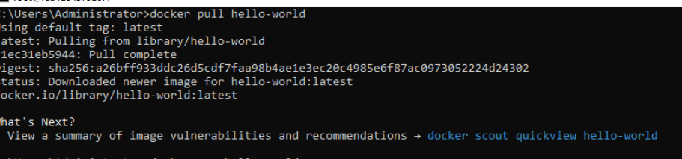

### **Docker images**

Displays the list of docker images.

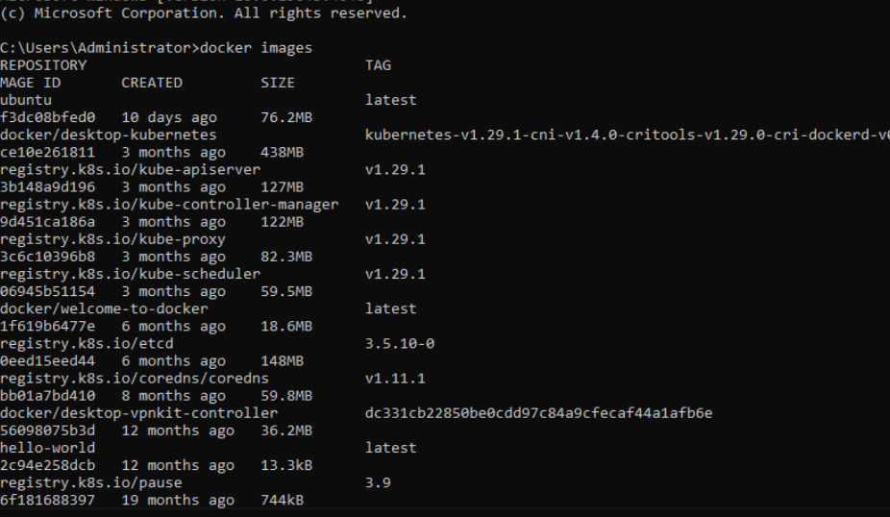

### **Docker run**

Executes the images in a container.

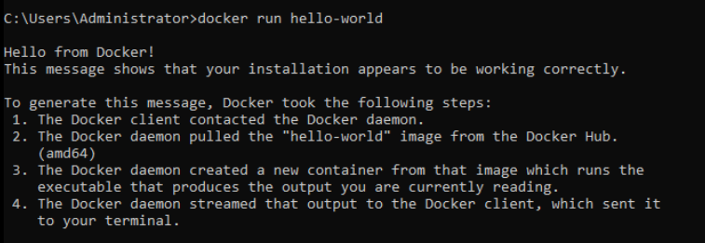

### **Docker ps -a**

Displays all the containers in the system



Pulling ubuntu from registry

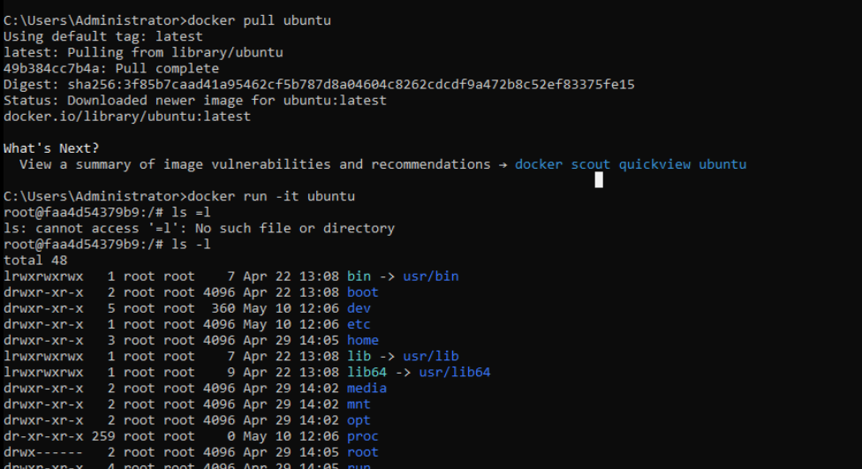

### **Docker container ls**

Display only running container

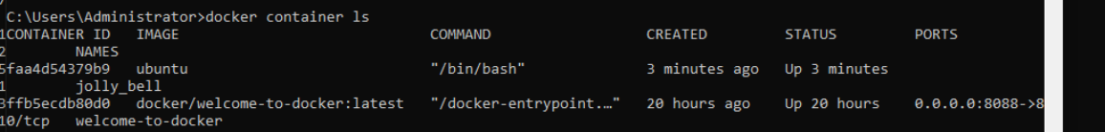

### **Docker top**

Displays top processes running inside a container

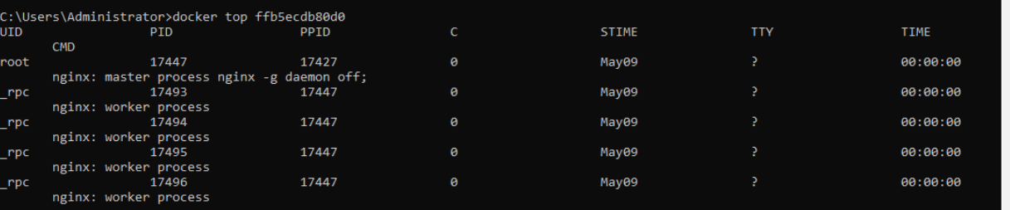

### **Docker stop**

Stops the running container

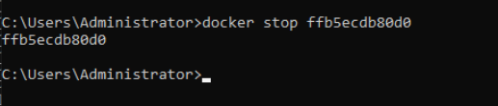

### **Docker Kill**

Abruptly kills the container.

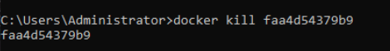

### **Docker exec**

Docker exec <container id> <command>

Executes the given command in the given container.

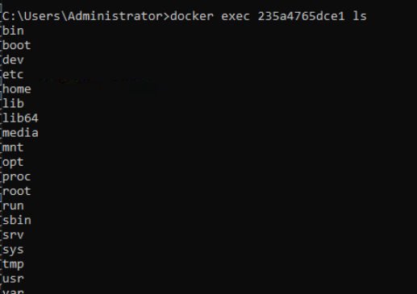

Docker info.

Provides information about Client and docker server

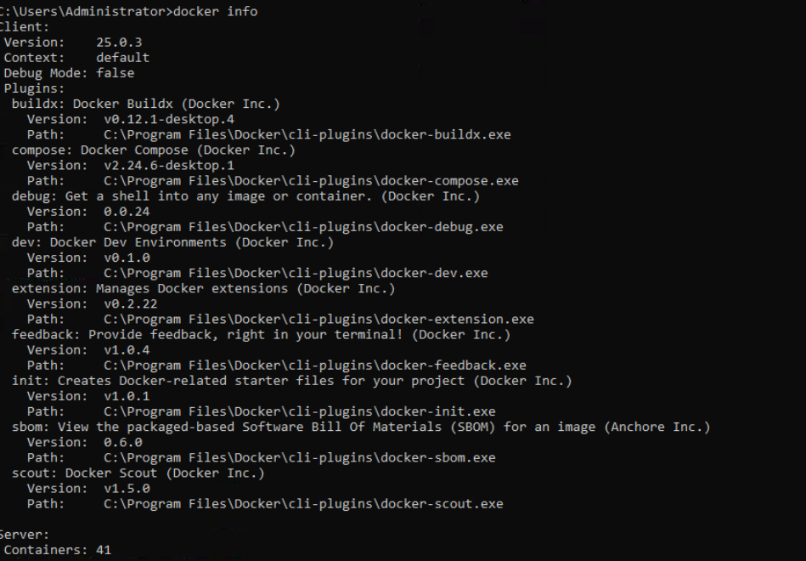

### **Docker inspect**

Gives more detailed information about the container

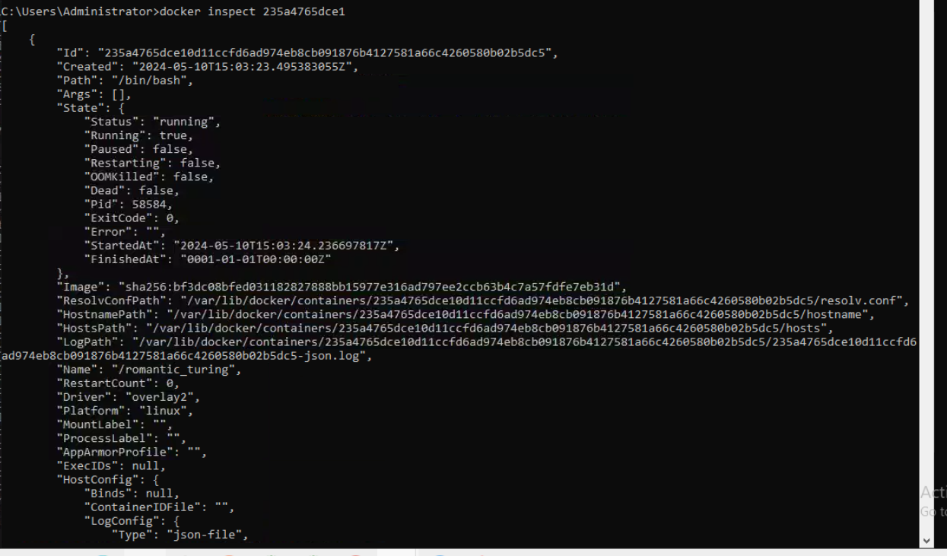

### **Docker rm**

Removes the container

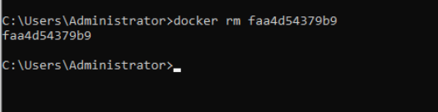

### **Docker rmi**

Removes the image from the list of images.  Image should not be referenced by any container.  If it is referencing then that container should be removed first with docker rm command and then use docker rmi to remove the image from the server.

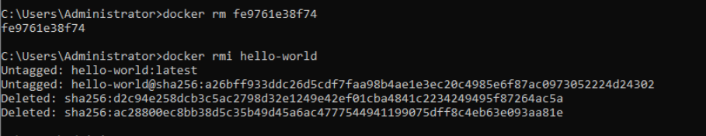

Docker help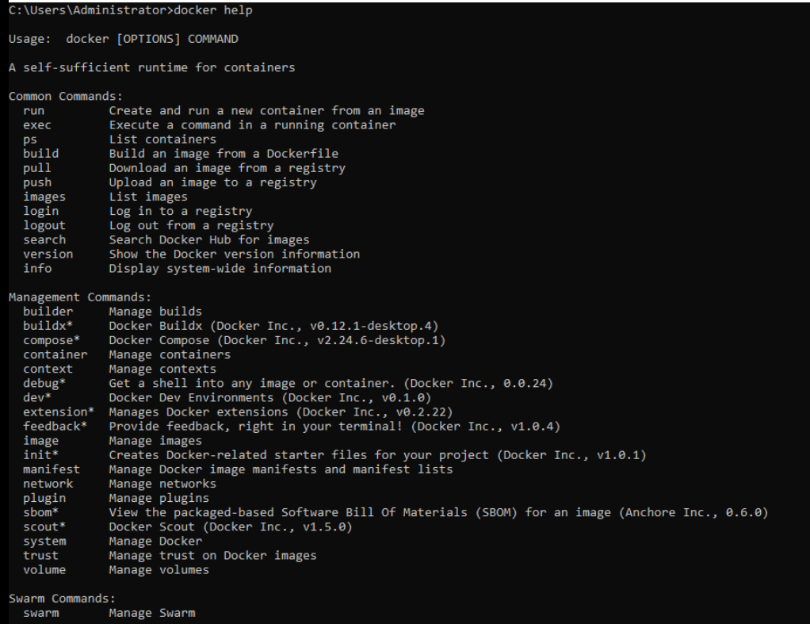

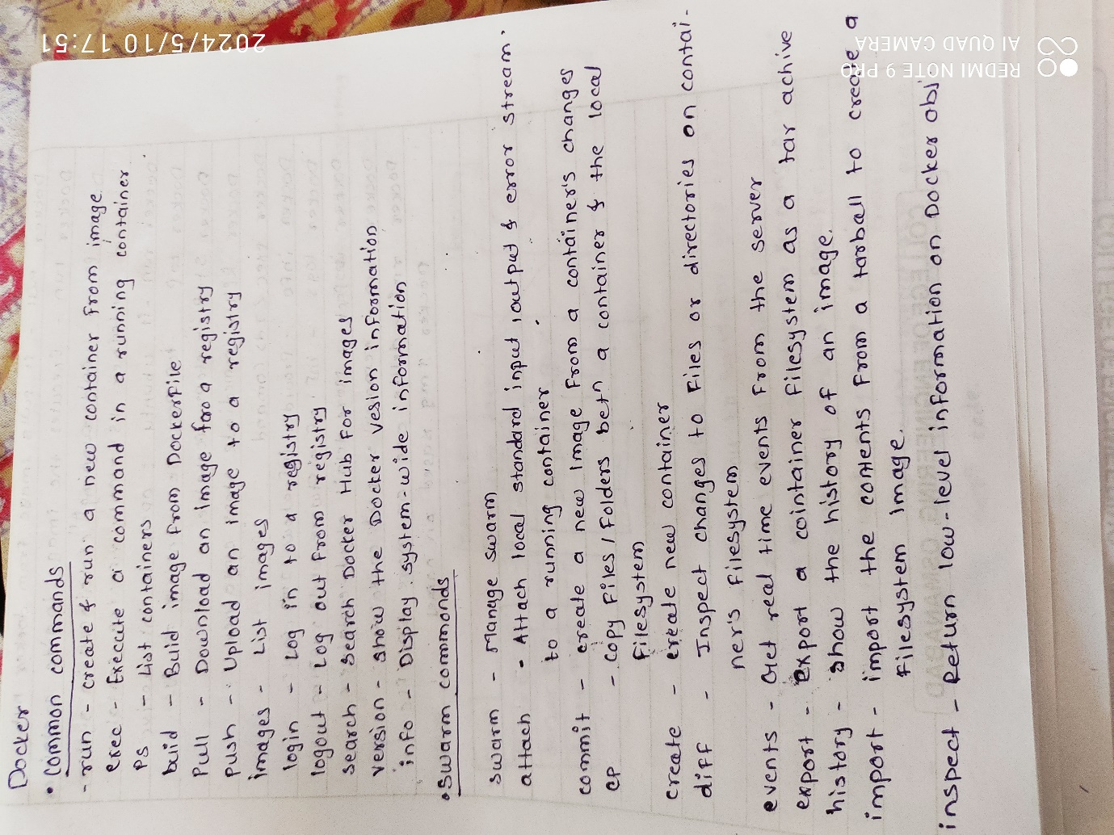

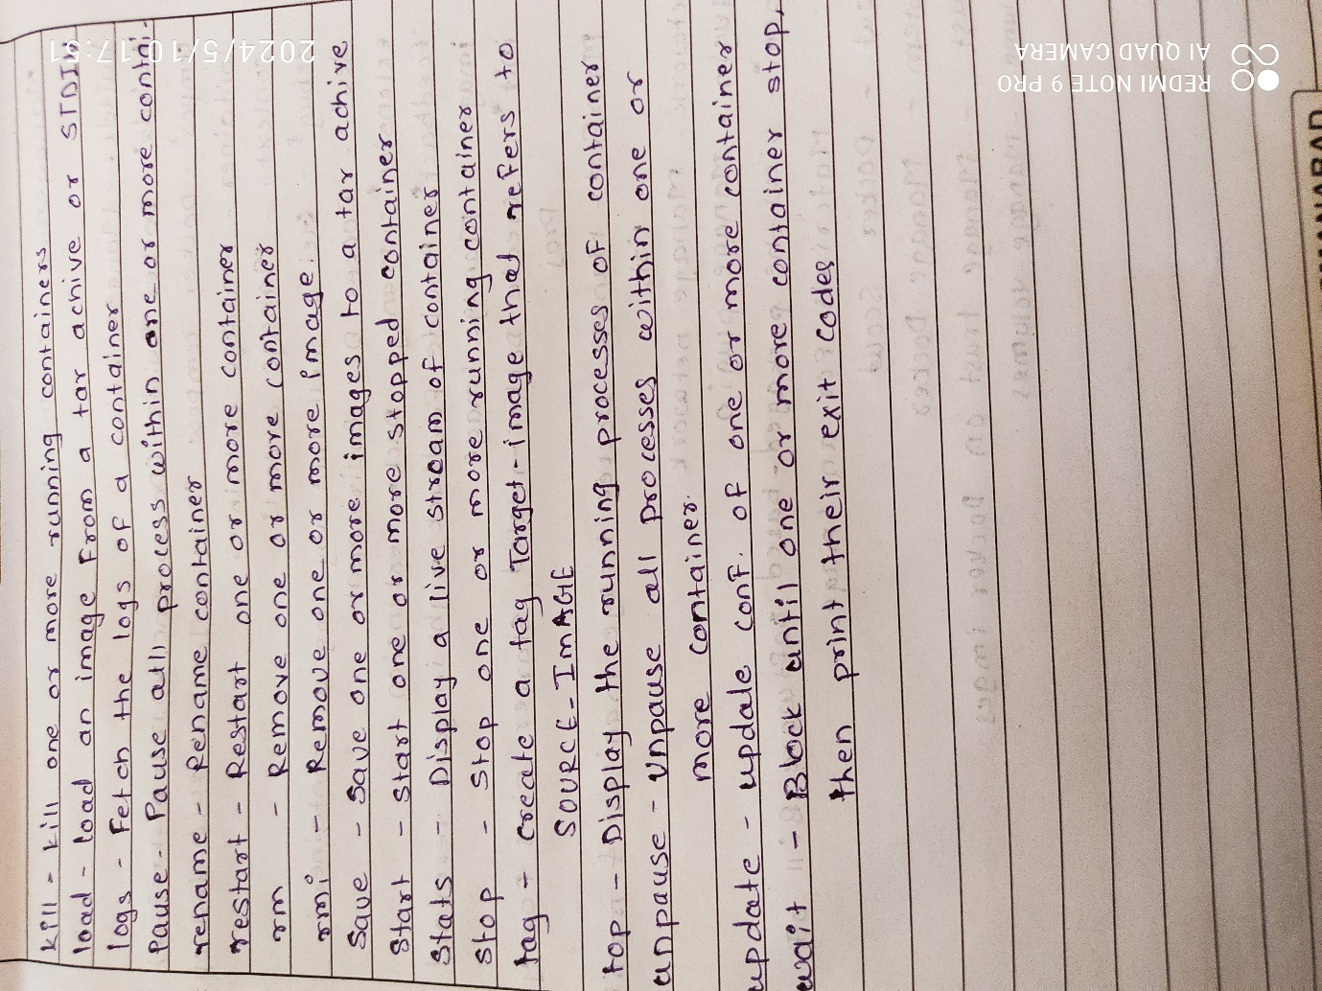

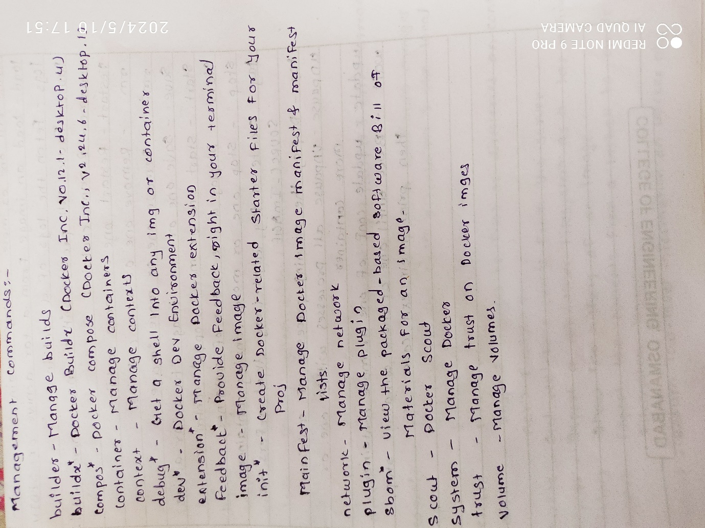

# Day::17

### **Docker Build with dockerfile.**

Step  1 : Create a Dockerfile as given below. Name it as Dockerfile.txt

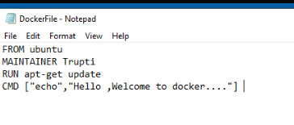

Step 2 : Execute this docker file using docker build command.



Step 3 : verify that images is created using docker images command.

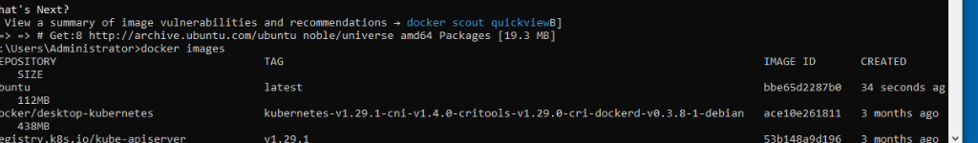

Step 4 : Run the container and echo message should display from the container.

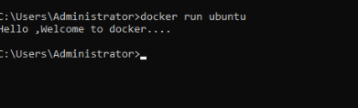

### **Docker compose**

Step 1 : Create a file named docker-compose.yml and have the below yml file entered in it

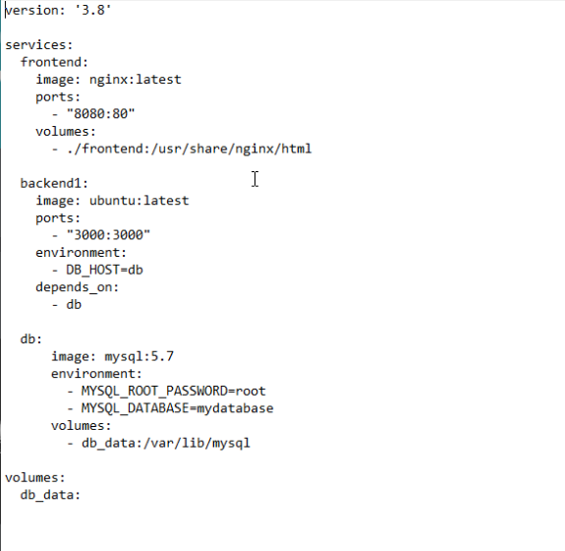

Step 2 : Remove all unwanted container and images. Do not remove the images and containers of kubernetes which starts with k8.

Step 3 : Run  → docker compose up in the command prompt where docker-compose.yml is present.

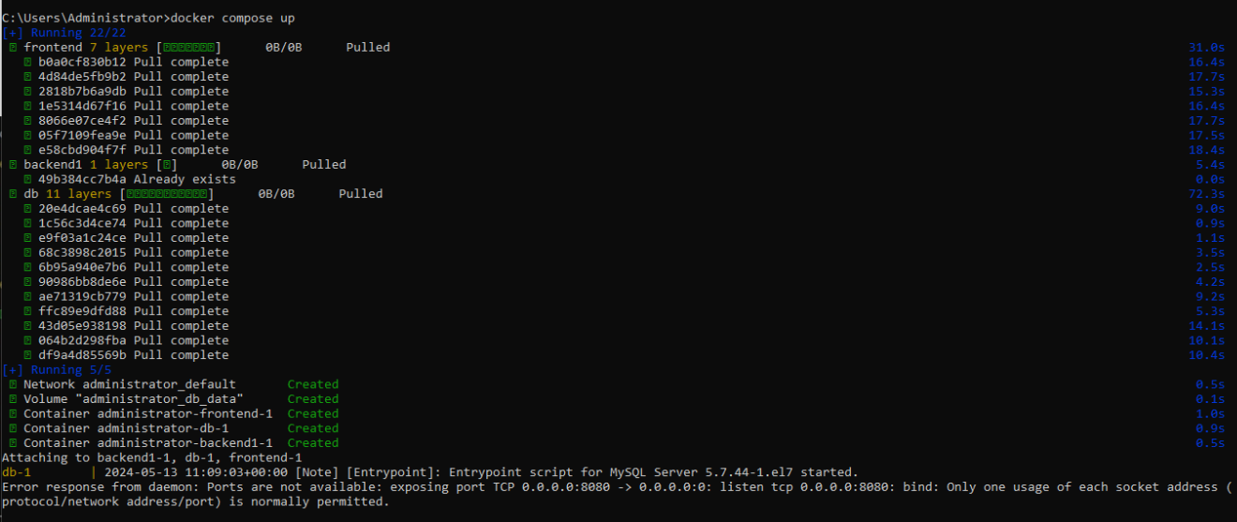

Step 4 : verify whether the images are downloaded by docker compose with docker images command.

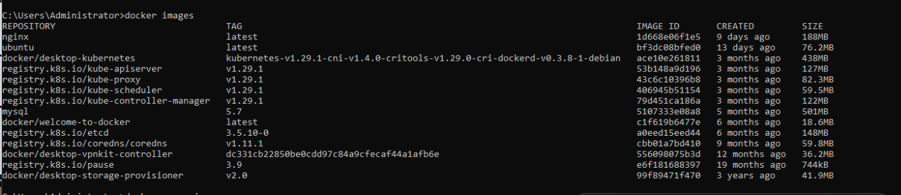

Step 5 : Verify that containers are brought up by docker compose command using docker ps -a

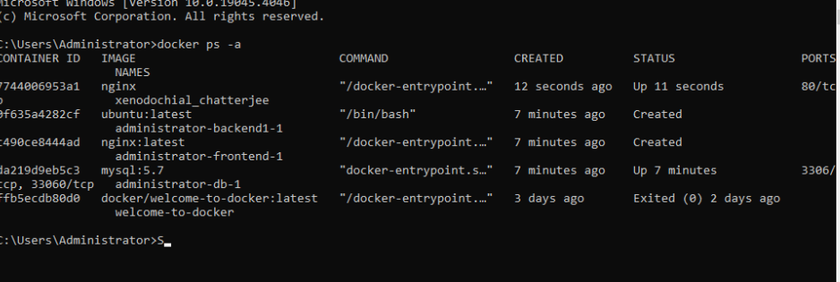

Docker volume

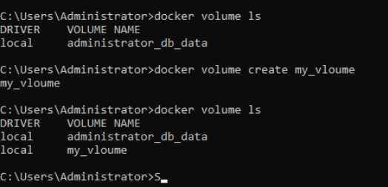

# Day-18

# Kubernetes

## Node information

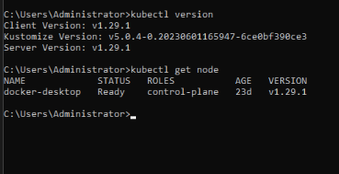

## Describe node

### Provides more details about the node

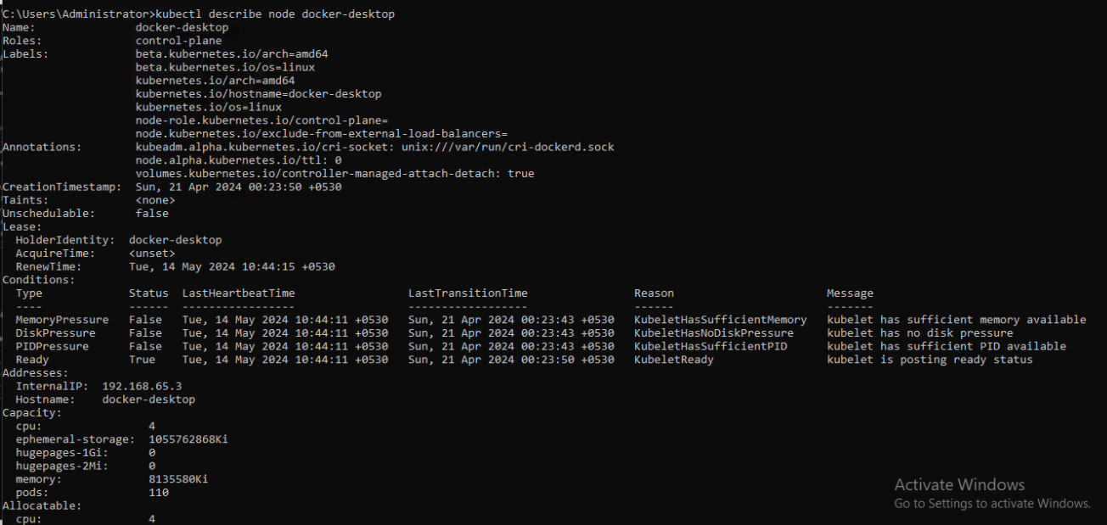

# Cluster Info

## Provides information about the cluster

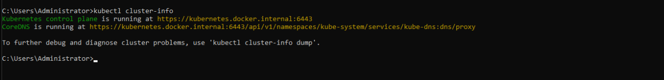

Cluster

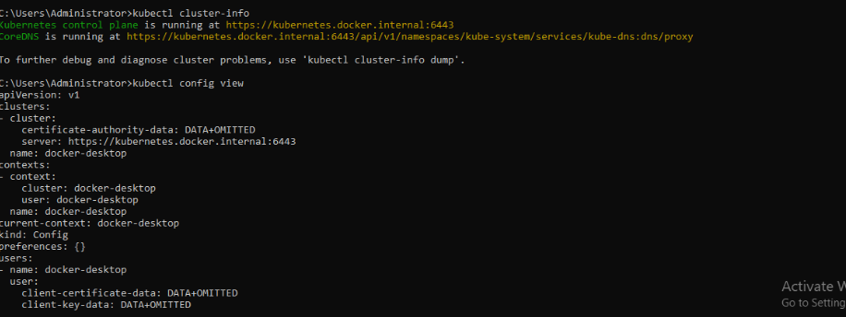

# PODS

## Create a pod and get info about pod

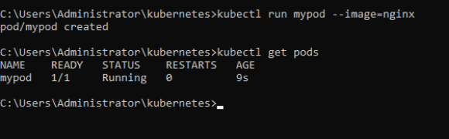

# Describe pod

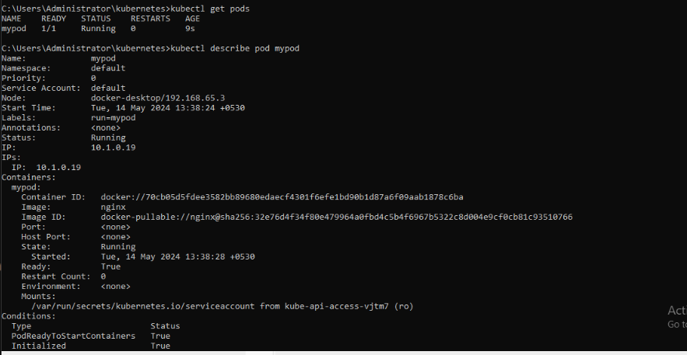

Api versions

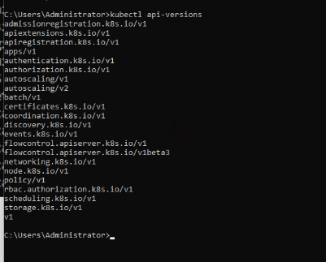

J

### **Execute a command in a pod**

Kubectl exec <pod name> <command> is the syntax.

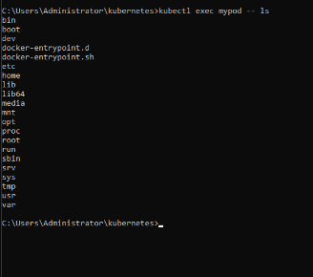

Execute in interactive mode.

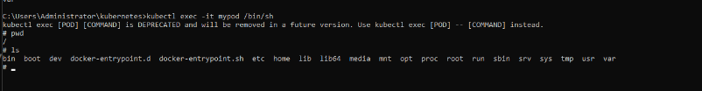

Show labels for pod

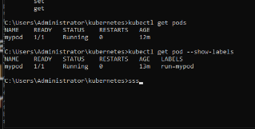

Pod info in json format

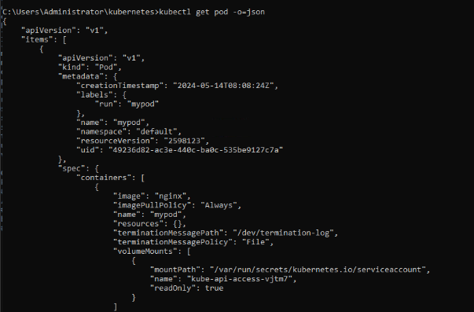

### **Pod info in yaml format**

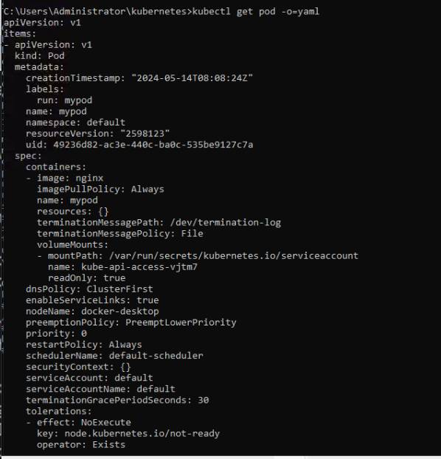

Get pod info in wide format

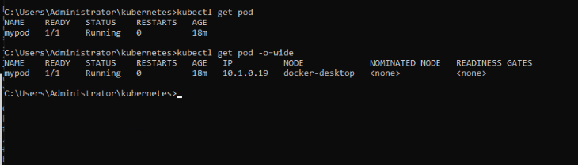

Get pod logs

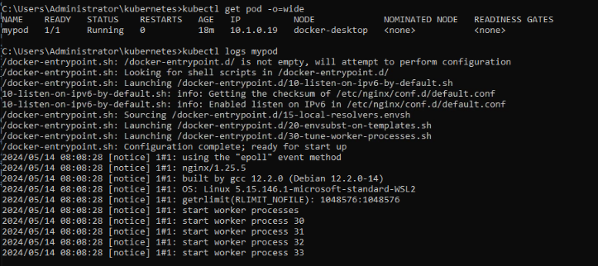

Get logs from last 1 hr.

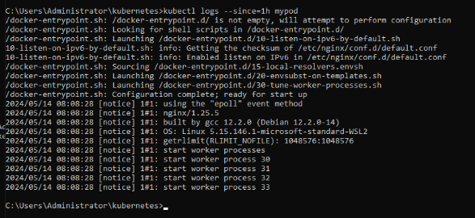

### **Display last n lines of logs from a pod**

Below given command will display last 10 lines from the logs of the pod mypod.

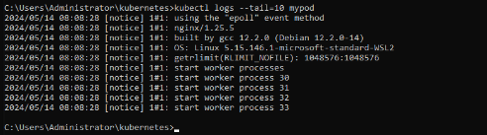

Create a deployment

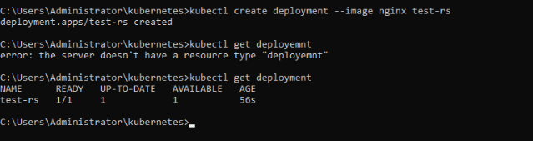

Describe deployment

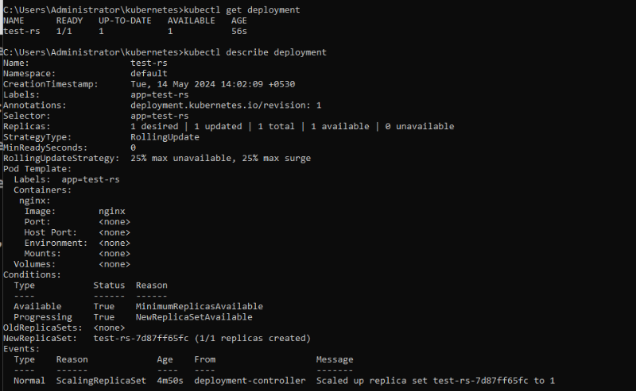

Kubectl get all

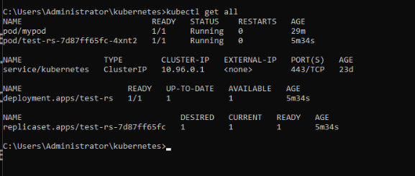

Delete deployment

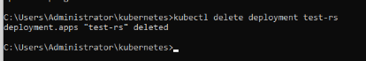

### **Single Container in a pod using yaml file**

Install the YAML extension in visual studio.  Steps for this is:

1. Click on extension icon  in visual studio.
2. 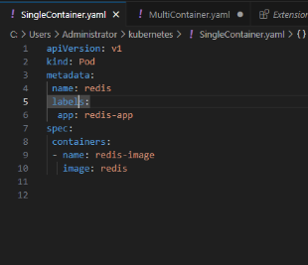

Step 2 : Apply this file using kubectl apply command as given below:

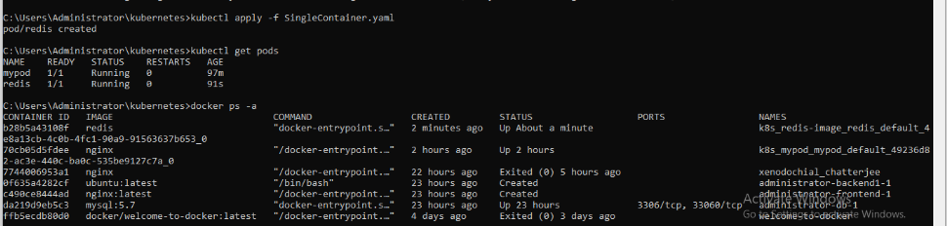

Step 3 : More information about the pod using kubectl describe pod command

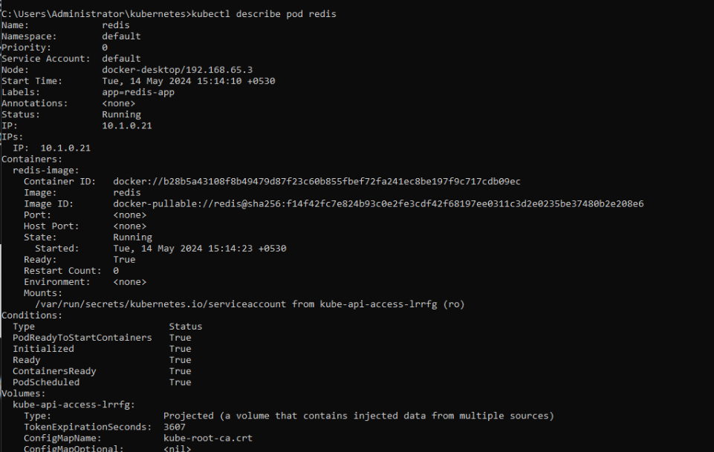

Step 4 : Delete the pod to see the next script executed.

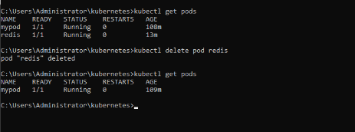

Multi Container in a pod

Step 1 : Create MultiContainer.yml file as given below:

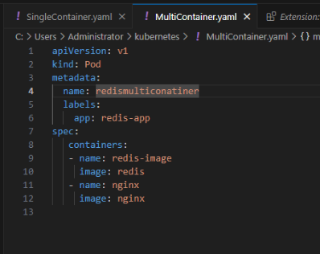

Step 2: Run this file using kubectl apply -f

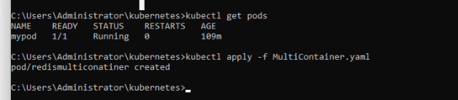

Step 3 : Verify that pods and containers are created.

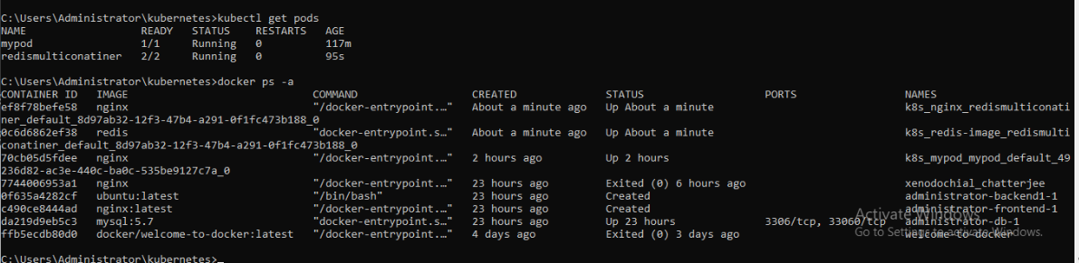

Step 4 : View more details about Pod containers using kubectl describe command

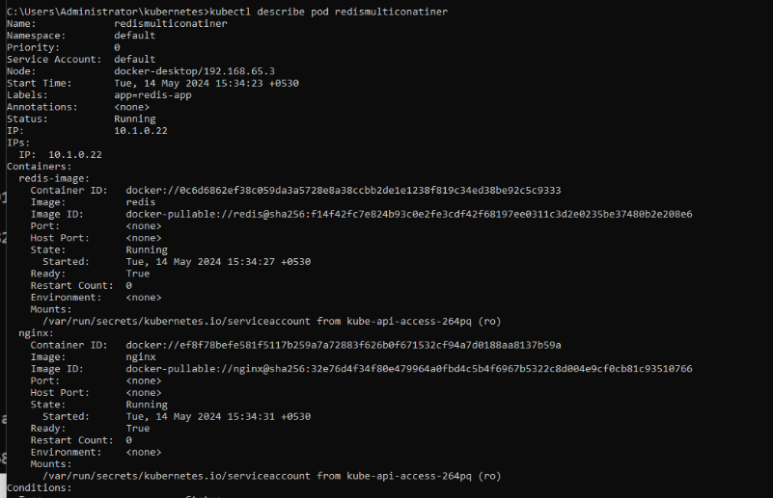

Step 5 : Delete the pods so that you can see the next set of pods / Services / Replica Sets/Deployments.

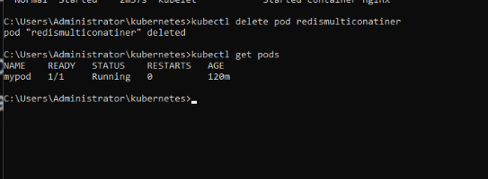

Wipro Training

# **Day-19**

### **Services**

Step 1 : Create a Service.yml file and have the following code:

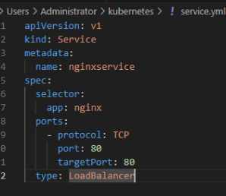

Step 2 : Run the service using kubectl apply -f <service yml file name>



Step 3 : Verify that service is created using the commands kubectl get Service and kubectl describe service <service name>

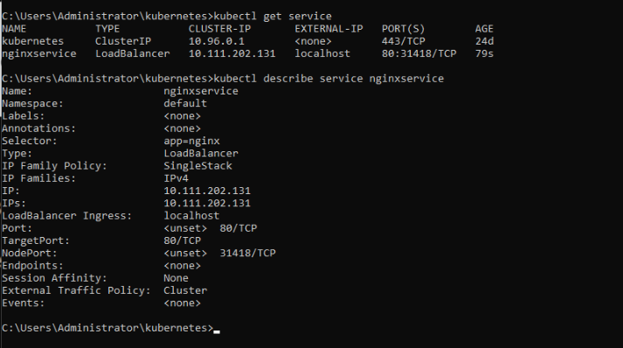

Step 4 : Delete the service and ensure that service is deleted.

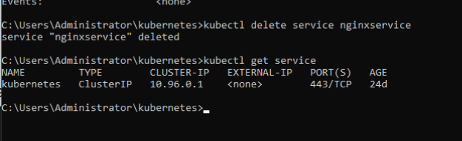

### **Replicaset**

Step 1: Create a replicasettemp.yml and have the following yml file script in it.

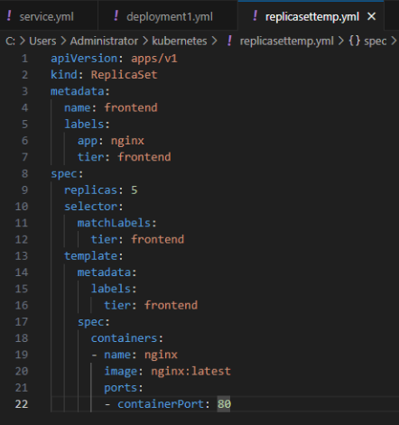

Step 2 : Create the replicaset with kubectl apply -f command

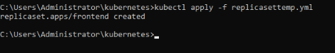

Step 3 : Verify the replicaset is working or not

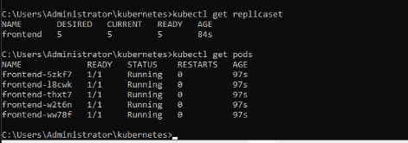

Step 4 :  Delete the replicaset

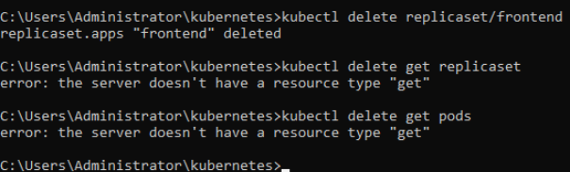

### **Batch job**

Step 1 : Create a job1.yml file

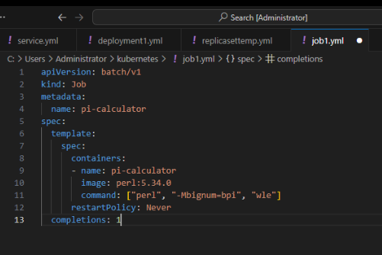

Step 2 : Run it and verify that batch job is created.

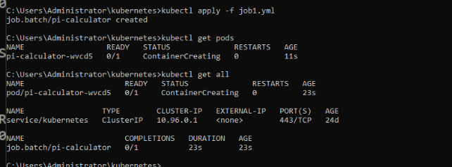

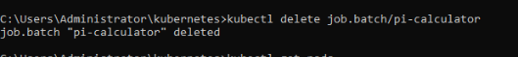

### **Deployment**

Step 1 : Create a yml file named deployment1.yml

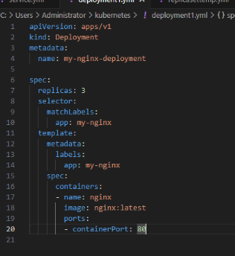

Step 2 : Run the yml and verify the result

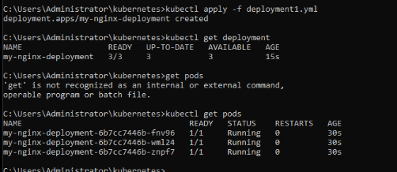

### **Volume**

Step 1 : Create volume1.yml with the following script

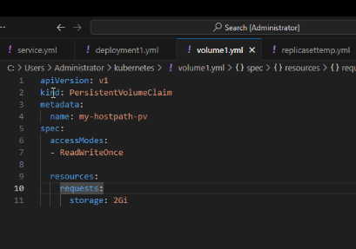

Step 2 : Run the yml file with kubectl apply -f and verify the volume is allocated or not with kubectl get pvc and kubectl describe <pvc name>

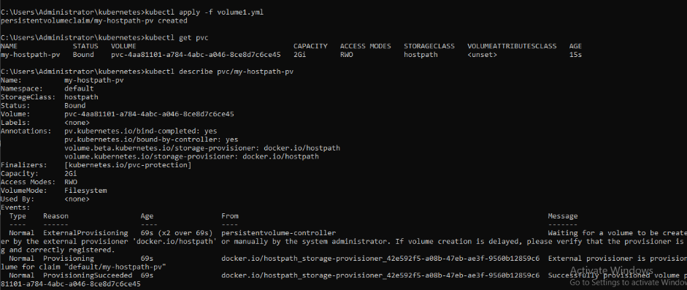

# **Day-20**

### **Rollout and rollback the deployment**

Step 1 : Have the deployment1.yml file as given below:

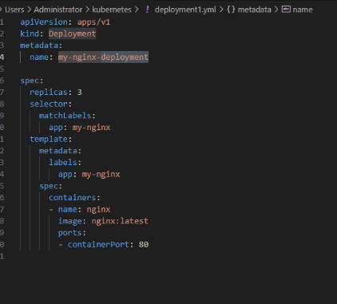

Stp 2: Apply this yml file for the deployment

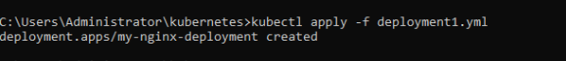

Step 3 : Verify the deployment is successfully done or not.

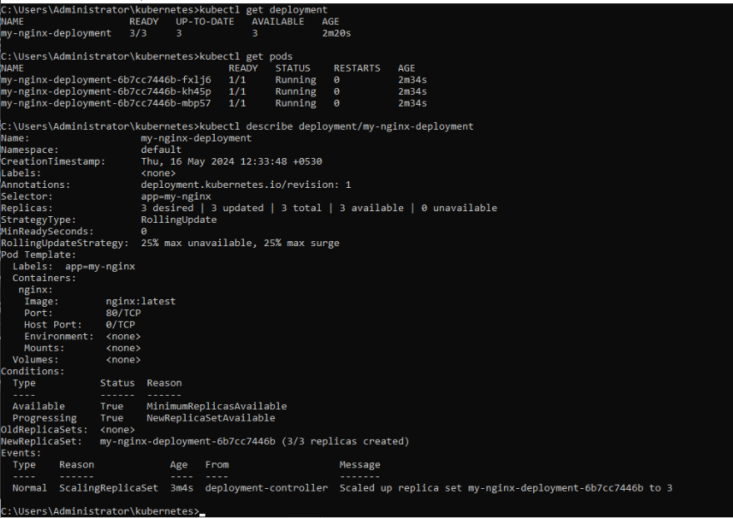

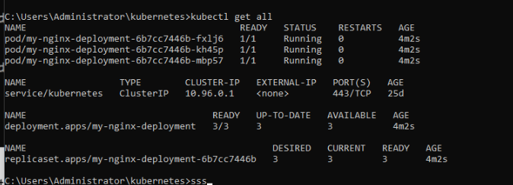

Step 4: Edit the deployment and modify the yml file

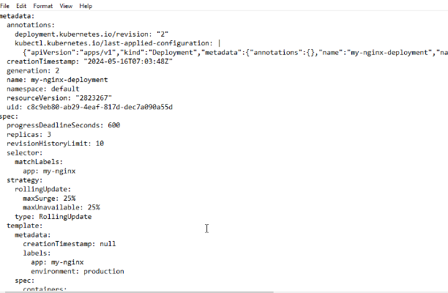

Save the file and exit the file.



Step 5 : Use the kubectl rollout status for updating the deployment with the latest changes.



Step 6 : look at the version history of the deployment

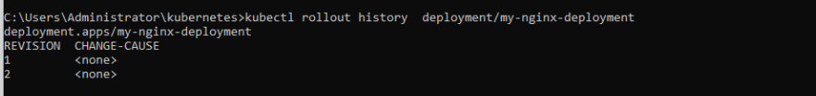

Step 7 : See the each version changes using kubectl rollout history with a tag of –revision in it

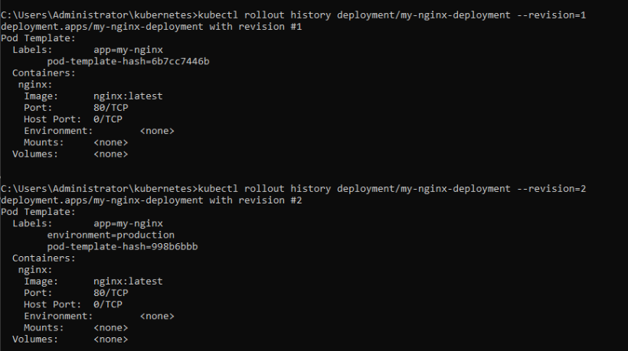

Step 8 : Revert back to old build as I dont want to have this environment for production.



Step 9 : Verify the build reverted back to the old build by giving kubectl edit command.

Verify in the yml file of deployment1.yml that environment=production is removed, that means the build reverted to the old build with the command kubectl rollout undo.

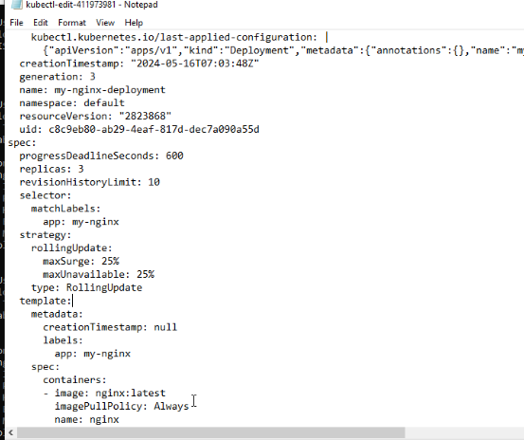

### **Manual scaling of deployment pods**

Step 1 : Delete the old deployments by using command

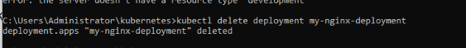

Kubectl delete deployment my-nginx-deployment

Step2 : Apply the deployment1.yml.  This will create a deployment with 3 replicas of the same pod.

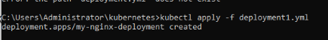

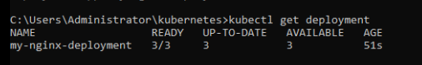

Step 3 : Verify the deployment is done with 3 pods.

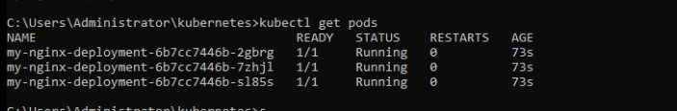

Step 4 : Increase the pods from 3 to 10 by using kubectl scale command



Step 5 : Verify that number of pods are increased to 6 from 3.

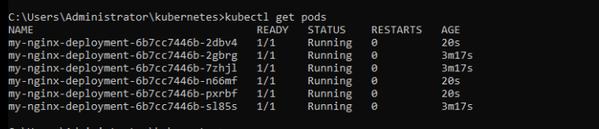

### **Auto scaling**

Step 1 : Delete the old deployment

Kubectl delete deployment/my-nginx-deployment

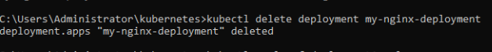

Step 2: Apply the new deployment

Kubectl apply -f deployment1.yml

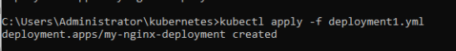

Step 3 : Auto scale the pods based on cpu. If the cpu % of the pod has reached 1%, replicate the pods / copy the pods to 15.  Minimum to 15 and maximum 20.



Step 4 : Verify that auto scaling is done:

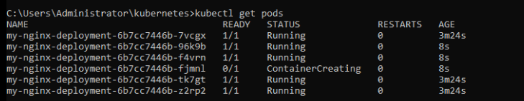

Sep 5 : Verify that HPA (Horizontal Auto Scaler) is shown kubectl get all

